**1** Figure 1 is a Venn diagram showing the number of students in a class who read any of three popular magazines *A*, *B* and *C*.

**Figure 1**

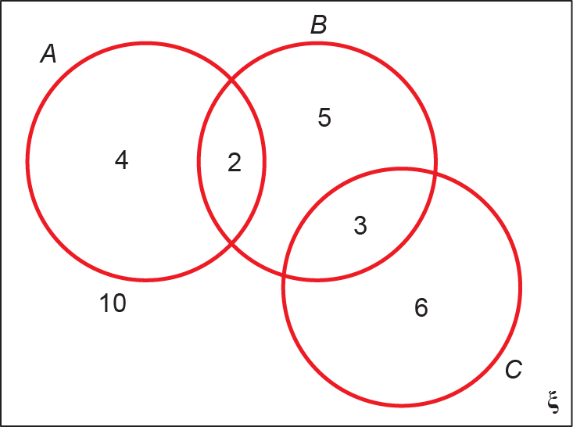

One of these students is selected at random.

**a** Show that the probability that the student reads more than one magazine is. **(2 marks)**

**b** Find the probability that the student reads *A* or *B* (or both). **(2 marks)**

**c** Write down the probability that the student reads both *A* and *C* and explain what this probability tells you about *A* and *C*. **(2 marks)**

**d** Given that the student reads at least one of the magazines, find the probability that the student reads *C*. **(1 mark)**

**e** Determine whether or not reading magazine *B* and reading magazine *C* are independent. **(3 marks)**

**2** A jar contains 2 red, 1 blue and 1 green bead. Two beads are drawn at random from the jar without replacement.

**a** Draw a tree diagram to illustrate all the possible outcomes and associated probabilities. Show your probabilities clearly. **(3 marks)**

**b** Find the probability that a blue bead and a green bead are drawn from the jar. **(2 marks)**

**3** There are 180 students at a college following a general course in computing. Students on this course can choose to take up to three extra options.

112 take systems support,

70 take developing software,

81 take networking,

35 take developing software and systems support,

28 take networking and developing software,

40 take systems support and networking,

4 take all three extra options.

**a** Draw a Venn diagram to represent this information. **(5 marks)**

A student from the course is chosen at random.

**b** Find the probability that this student takes

**i** none of the three extra options **(1 mark)**

**ii** networking only. **(1 mark)**

Students who take systems support and networking are eligible to become technicians.

**c** Given that the randomly chosen student is eligible to become a technician, find the probability that this student takes all three extra options. **(2 marks)**

**4** On a randomly chosen day the probability that Bill travels to school by car, by bicycle or on foot is,andrespectively. The probability of being late when using these methods of travel is ,andrespectively.

**a** Draw a tree diagram to represent this situation. **(3 marks)**

**b** Find the probability that on a randomly chosen day

**i** Bill travels by foot and is late **(2 marks)**

**ii** Bill is not late. **(2 marks)**

**5** A company assembles drills using components from two sources. Goodbuy supplies the components for 85% of the drills whilst Amart supplies the components for the rest.

**a** Represent this information on a tree diagram. **(3 marks)**

An assembled drill is selected at random.

**b** Find the probability that the drill is not faulty. **(3 marks)**

**6** Figure 2 is a histogram showing the distribution of the time taken in minutes, *t*, by a group of people to swim 500 m.

**Figure 2**

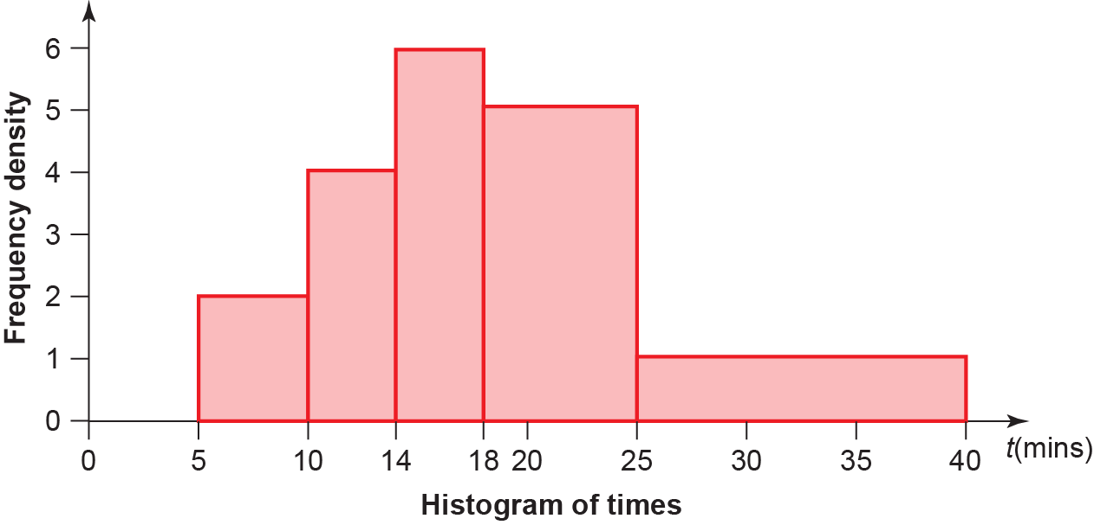

**a** Find the probability that a person chosen at random from the group takes longer than 18 minutes. **(4 marks)**

**b** Estimate the probability that a person chosen at random from the group takes less than 30 minutes. **(3 marks)**

**7** A researcher measured the foot lengths of a random sample of ten-year-old children. The lengths are summarised in the table below.

|  |  |
| --- | --- |
| Foot length, *l*, (cm) | Number of children |
| 10 ⩽ *l* < 12 | 5 |
| 12 ⩽ *l* < 17 | 52 |
| 17 ⩽ *l* < 19 | 30 |
| 19 ⩽ *l* < 21 | 15 |
| 21 ⩽ *l* < 23 | 11 |
| 23 ⩽ *l* < 25 | 7 |

**a** Find the probability that a child chosen at random has a foot length less than 17 cm. **(3 marks)**

**b** Find the probability that a child chosen at random has a foot length between 12 cm and 18 cm. State one assumption you have made. **(3 marks)**