**Year 13 Pure Maths Homework Booklet**

**Name:____________________________________**

**Maths Teachers:____________________________**

**Contents**

**Page 2: Proof**

**Page 4: Algebraic and partial fractions**

**Page 6: Functions and Modelling**

**Page 9: Sequences and Series**

**Page 11: The Binomial Theorem**

**Page 13:** Trigonometry

**Page 17: Parametric Equations**

**Page 21: Differentiation**

**Page 24: Numerical Methods**

**Page 28: Integration (part 1)**

Page 32: Integration (Part 2)

**Page 37: Vectors**

**Proof**

**1** Prove by exhaustion that  for positive integers from 1 to 6 inclusive. **(3 marks)**

**2** Use proof by contradiction to prove the statement: ‘The product of two odd numbers is odd.’ **(5)**

**3** Prove by contradiction that if *n* is odd, *n*3+ 1 is even. **(5 )**

**4** Use proof by contradiction to show that there exist no integers *a* and *b* for which

25*a* + 15*b* = 1. **(4 )**

**5** Use proof by contradiction to show that there is no greatest positive rational number. **(4 )**

**6** Use proof by contradiction to show that, given a rational number *a* and an irrational number *b*, *a* − *b* is irrational. **(4 )**

**7** Use proof by contradiction to showthat there are no positive integer solutions to the statement  **(5 )**

**8** **a** Use proof by contradiction to show that if *n*2 is an even integer then *n* is also an even integer. **(4 )**

**b** Prove thatis irrational. **(6 )**

**9** Prove by contradiction that there are infinitely many prime numbers. **(6 )**

**Algebraic and partial fractions**

**1** Given that 

find the values of the constants *A*, *B* and *C*, where *A*, *B* and *C* are integers. **(5 )**

**2** Show that  can be written in the form 

Find the values of the constants *A* and *B*. **(5 )**

**3 **

Given that f (*x*) can be expressed in the form 

find the values of *A*, *B* and *C*. **(6 )**

**4** 

Find the values of the constants *A*, *B* and *C*. **(6 )**

**5** 

Show that f (*x*) can be written as  and find the values of *P*, *Q*, *R*, *V* and *W*. **(7 )**

**6** Find the values of the constants *A*, *B*, *C*, *D* and *E* in the following identity:  **(5 )**

**7** 

Show that f (*x*) can be written in the form , where *A*, *B* and *C* are constants to be found. **(7 )**

**Functions and Modelling**

**1** , *x*∈ℝ

**a** Sketch the graph of *y* = f(*x*), labelling its vertex and any points of intersection with the coordinate axes. **(5 )**

**b** Find the coordinates of the points of intersection of and **(5 )**

**2** The functions p and q are defined by  and 

**a** Given that pq(*x*)= qp(*x*), show that  **(4 )**

**b** Explain why  has no real solutions. **(2 )**

**3** The function g(*x*) is defined by, *x*∈ℝ, *x* > 4. Find g−1(*x*) and state its domain and range. **(6 )**

**4** The diagram shows the graph of h(*x*).

**Figure 1**

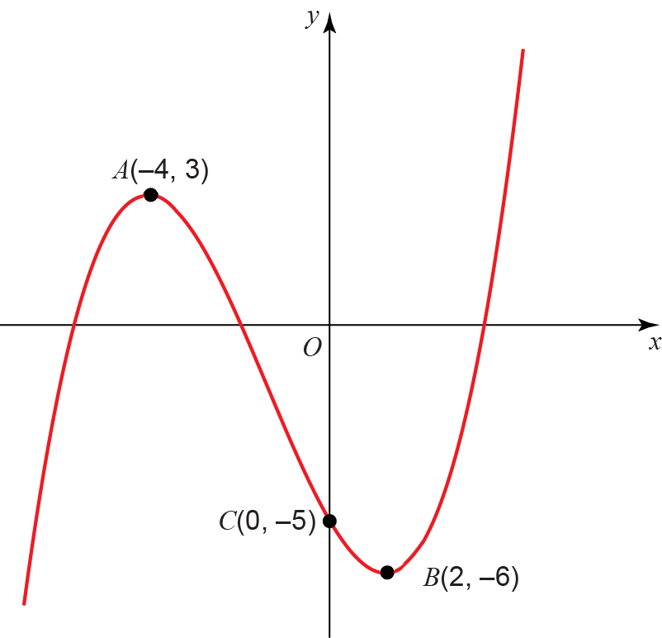

The points *A*(−4, 3) and *B*(2, −6) are turning points on the graph and *C*(0, −5) is the *y*-intercept. Sketch on separate diagrams, the graphs of

**a** *y* = |f(*x*)| **(3 )**

**b** *y* = f(|*x*|) **(3 )**

**c** *y* = 2f(*x* + 3) **(3 )**

Where possible, label clearly the transformations of the points *A*, *B* and *C* on your new diagrams and give their coordinates.**5** The diagram shows a sketch of part of the graph *y* = f(*x*) where 

**Figure 2**

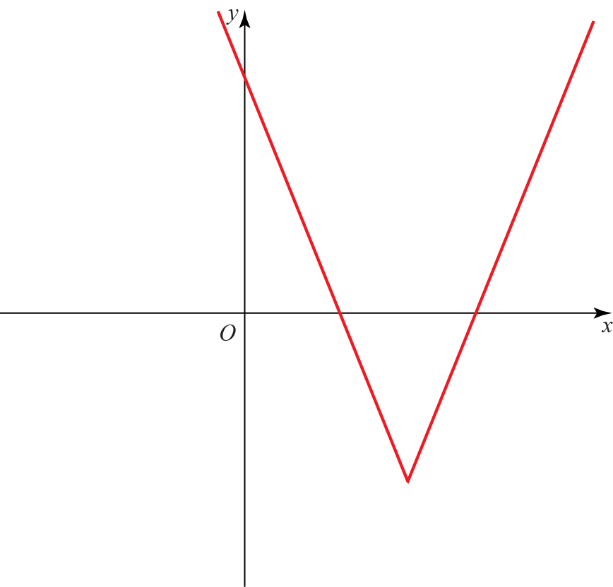

**a** State the range of f. **(1 )**

**b** Given that , where *k* is a constant has two distinct roots, state the possible values of *k*. **(7 )**

**6** The temperature of a mug of coffee at time *t* can be modelled by the equation , where is the temperature, in °C, of the coffee at time *t* minutes after the coffee was poured into the mug and  is the room temperature in °C.

**a** Using the equation for this model, explain why the initial temperature of the coffee is independent of the initial room temperature. **(2 )**

**b** Calculate the temperature of the coffee after 10 minutes if the room temperature is 20 °C. **(2 )**

**Sequences and Series**

**1** The first 3 terms of a geometric sequence are , . Find the value of *k*. **(4 )**

**2** For an arithmetic sequence and

**a** Find the value of the 20th term. **(4 )**

**b** Given that the sum of the first *n* terms is 78, find the value of *n*. **(4 )**

**3** **a** Prove that the sum of the first *n* terms of an arithmetic series is

 **(3 )**

**b** Hence, or otherwise, find the sum of the first 200 odd numbers. **(2 )**

**4** A sequence is given by, where *p* is an integer.

**a** Show that **(2 )**

**b** Given that, find the value of *p*. **(3 )**

**c** Hence find the value of. **(1 )**

**5** A ball is dropped from a height of 80 cm. After each bounce it rebounds to 70% of its previous maximum height.

**a** Write a recurrence relation to model the maximum height in centimetres of the ball after each subsequent bounce. **(2 )**

**b** Find the height to which the ball will rebound after the fifth bounce. **(2 )**

**c** Find the total vertical distance travelled by the ball before it stops bouncing. **(4 )**

**d** State one limitation with the model. **(1 )**

**6** At the beginning of each month Kath places £100 into a bank account to save for a family holiday. Each subsequent month she increases her payments by 5%. Assuming the bank account does not pay interest, find

**a** the amount of money in the account after 9 months. **(3 )**

Month *n* is the first month in which there is more than £6000 in the account.

**b** Show that  **(4 )**

Maggie begins saving at the same time as Kath. She initially places £50 into the same account and plans to increase her payments by a constant amount each month.

**c** Given that she would like to reach a total of £6000 in 29 months, by how much should Maggie increase her payments each month? **(2 )**

**7** An infinite geometric series has first four terms The series is convergent.

**a** Find the set of possible values of *x* for which the series converges. **(2 )**

**b** Given that , calculate the value of *x*. **(3 )**

**The Binomial Theorem**

**1** **a** Find the binomial expansion of  in ascending powers of *x* up to and including the *x*2 term, simplifying each term. **(4 )**

**b** State the set of values of *x* for which the expansion is valid. **(1 )**

**c** Show that when , the exact value of  is . **(2 )**

**d** Substitute  into the binomial expansion in part **a** and hence obtain an approximation to. Give your answer to 5 decimal places. **(3 )**

**2** Given that in the expansion of  the coefficient of the *x*2 term is 75 find:

**a** the possible values of *a* **(4 )**

**b** the corresponding coefficients of the *x*3 term. **(2 )**

**3** The first three terms in the binomial expansion of  are 

**a** Find the values of *a* and *b.* **(5 )**

**b** State the range of values of *x* for which the expansion is valid. **(2 )**

**c** Find the value of *c*. **(2 )**

**4** 

**a** Show that the first three terms in the series expansion of f(*x*) can be written as

 **(7 )**

**b** Find the exact value of f (0.01). Round your answer to 7 decimal places. **(2 )**

**c** Find the percentage error made in using the series expansion in part **a** to estimate the value of f (0.01). Give your answer to 2 significant figures. **(3 )**

Trigonometry

**1** Figure 1 shows a logo comprised of a rhombus surrounded by two arcs. Arc *BAD* has centre *C* and arc *BCD* has centre *A*. Some of the dimensions of the logo are shown in the diagram.

**Figure 1**

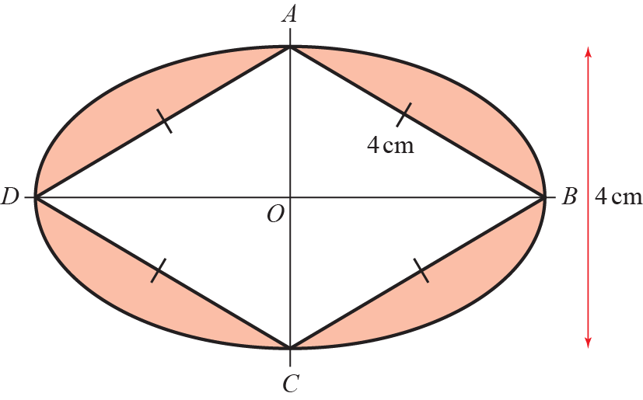

Prove that the shaded area of the logo is **(8 )**

**2** **a** When *θ* is small, show that the equationcan be written as  **(4 )**

**b** Hence write down the value of  when *θ* is small. **(1 )**

**3** **a** Prove that **(3 )**

**b** Hence solve, in the interval, the equation  **(3 )**

**4** Figure 2 shows the right-angled trianglesand, with and.

**Figure 2**

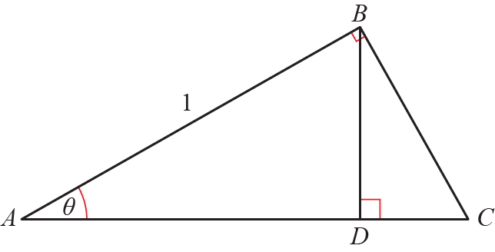

Prove that  **(8 )**

**5** Solve  in the range. Round your answer to 1 decimal place. **(4 )**

**6** **a** Prove that  **(3 )**

**b** Use the result to solve, for , the equation 

Give your answer in terms of π. Check for extraneous solutions. **(4 )**

**7** **a** Express  in the form , where *R* > 0 and 0 < *α* < π

Write *R* in surd form and give the value of *α* correct to 4 decimal places. **(4 )**

The temperature of a kiln, , used to make pottery can be modelled by the equation  where *x* is the time in hours since the pottery was placed in the kiln.

**b** Calculate the maximum value of *T* predicted by this model and the value of *x*, to 2 decimal places, when this maximum first occurs. **(4 )**

**c** Calculate the times during the first 24 hours when the temperature is predicted, by this model, to be exactly 1097 °C. **(4 )**

**Parametric Equations**

**1** *C* has parametric equations ,, 

**a** Show that the cartesian equation of *C* is,over an appropriate domain. **(4 )**

Given that *C* is a line segment and that the gradient of the line is −1,

**b** show that the length of the line segment is, where *a* is a rational number to be found. **(4 )**

**2** A curve *C* has parametric equations,,

Show that a cartesian equation of *C* isfor a suitable domain which should be stated. **(4 )**

**3** The curve *C* has parametric equations,,

**a** Show that the cartesian equation of *C* can be written as, where *a*, *b* and *c* are integers which should be stated. **(3 )**

**b** Sketch the curve *C* on the given domain, clearly stating the endpoints of the curve. **(3 )**

**c** Find the length of *C*. Leave your answer in terms of *π*. **(2 )**

**4** The diagram shows the curve *C* with parametric equations,, . The curve passes through the *x*-axis at *P*.

**Figure 1**

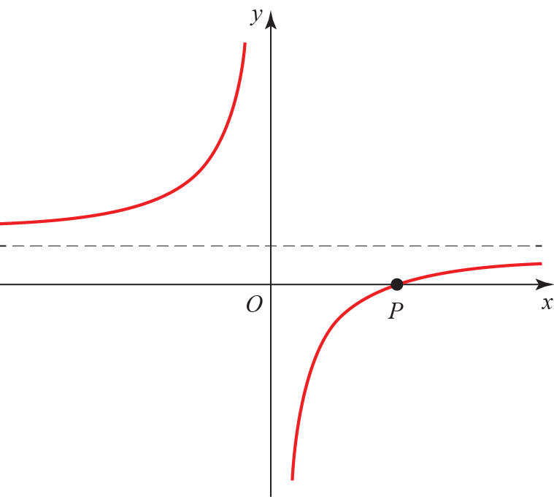

**a** Find the coordinate of *P*. **(2 )**

**b** Find the cartesian equation of the curve. **(2 )**

**c** Find the equation of the normal to the curve at the point *t =* −1. Give your answer in the form  **(6 )**

**d** Find the coordinates of the point where the normal meets *C*. **(4 )**

**5** A stone is thrown from the top of a building. The path of the stone can be modelled using the parametric equations,,  where *x* is the horizontal distance from the building in metres and *y* is the vertical height of the stone above the level ground in metres.

**a** Find the horizontal distance the stone travels before hitting the ground. **(4 )**

**b** Find the greatest vertical height. **(5 )**

**6** A large arch is planned for a football stadium. The parametric equations of the arch are, ,where *x* and *y* are distances in metres.

**a** Find the cartesian equation of the arch. **(3 )**

**b** Find the width of the arch. **(2 )**

**c** Find the greatest possible height of the arch. **(2 )**

**Differentiation**

1. **a**

Given that , show that

 **(4 )**

**b** Hence prove that **(2 )**

**2** A curve has the equation

Show that the equation of the tangent at the point with an *x*-coordinate of 1 is

 **(6 )**

**3** Given that, find:

**a** in terms of *y* **(2 )**

**b** Show that

where *k* is a constant which should be found. **(3 )**

**4** A curve *C* has equation for *x* > 0

Find the exact value ofat the point *C* with coordinates (2, 4). **(5 )**

**5** The curve *C* has equation

**a** Show that *C* is concave on the interval [–5, –3]. **(3 )**

**b** Find the coordinates of the point of inflection. **(3 )**

**6** In a rainforest, the area covered by trees, *F*, has been measured every year since 1990. It was found that the rate of loss of trees is proportional to the remaining area covered by trees. Write down a differential equation relating *F* to *t*, where *t* is the numbers of years since 1990. **(2)**

**7** The volume of a sphere *V* cm3 is related to its radius *r* cm by the formula

The surface area of the sphere is also related to the radius by the formula

Given that the rate of decrease in surface area, in cm2 s–1, is

find the rate of decrease of volume **(4 )**

**Numerical Methods**

**1** 

**a** Show that the equation f(*x*) = 0 can be written as, where *a* and *b* are constants to be found. **(2 )**

**b** Let *x*0 = 1.5. Use the iteration formula, together with your values of *a* and *b* from part **a**, to find, to 4 decimal places, the values of *x*1, *x*2, *x*3 and *x*4. **(2 )**

A root of f(*x*) = 0 is *α*.

**c** By choosing a suitable interval, prove that *α* = −2.782 to 3 decimal places. **(3 )**

**2** , –40 < *x* < 20, *x* is in radians.

**a** Show that the equation g(*x*) = 0 can be written as

 **(3 )**

**b** Using the formula,

find, to 3 decimal places, the values of *x*1, *x*2 and *x*3. **(2 )**

**3** , where *x* is in radians.

**a** Show that f(*x*) = 0 has a root *α* between *x* = 1.9 and *x* = 2.0. **(2 )**

**b** Using *x*0 = 1.95 as a first approximation, apply the Newton–Raphson procedure once to f(*x*) to find a second approximation to *α*, giving your answer to 3 decimal places. **(5 )**

**4 **

**a** By drawing an appropriate sketch, show that there is only one solution to the equation g(*x*) = 0 **(2 )**

**b** Show that the equation g(*x*) = 0 may be written in the form *x* = 2e−*x* + 1 **(2 )**

**c** Let *x*0 = 1.5. Use the iterative formulato find to 4 decimal places the values of *x*1, *x*2, *x*3 and *x*4. **(2 )**

**d** Using *x*0 = 1.5 as a first approximation, apply the Newton–Raphson procedure once to g(*x*) to find a second approximation to *α*, giving your answer to 4 decimal places. **(4 )**

**5** 

The graph *y* = h(*t*) models the height of a rocket *t* seconds after launch.

**a** Show that the rocket returns to the ground between 19.3 and 19.4 seconds after launch. **(2 )**

**b** Using *t*0 = 19.35 as a first approximation to *α*, apply the Newton–Raphson procedure once to h(*t*) to find a second approximation to *α*, giving your answer to 3 decimal places. **(5 )**

**c** By considering the change of sign of h(*t*) over an appropriate interval, determine if your answer to part **b** is correct to 3 decimal places. **(3 )**

**6 **

**Figure 1**

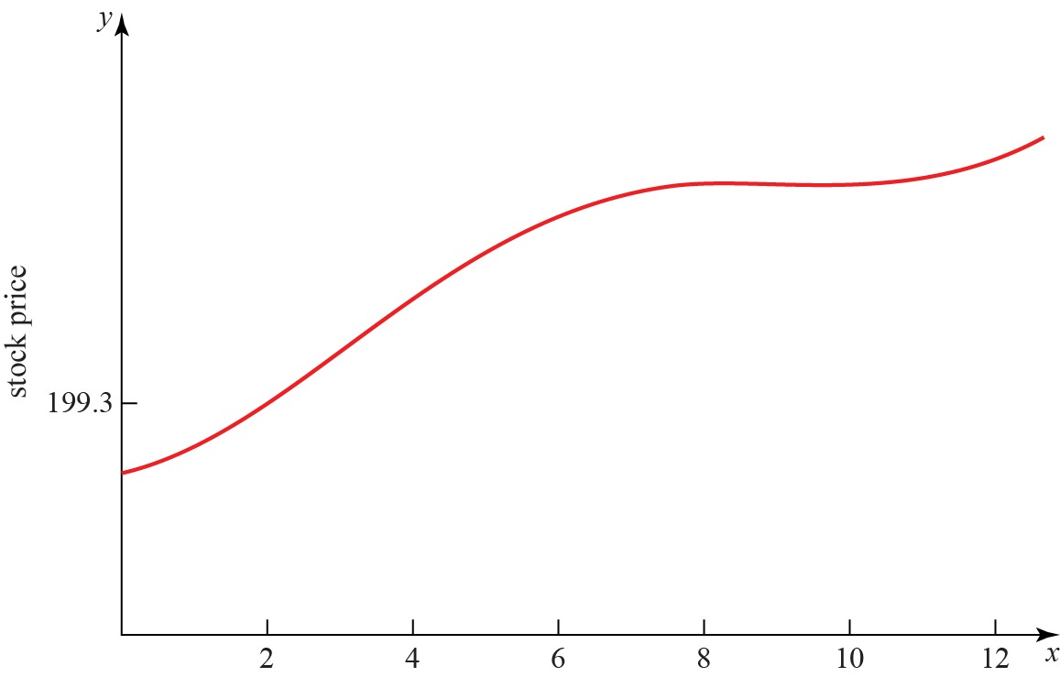

**a** Figure 1 is a graph of the price of a stock during a 12-hour trading window. The equation of the curve is given above. Show that the price reaches a local maximum in the interval . **(5 )**

**b** Figure 1 shows that the price reaches a local minimum between 9 and 11 hours after trading begins. Using the Newton–Raphson procedure once and taking t0 = 9.9 as a first approximation, find a second approximation of when the price reaches a local minimum. **(6 )**

**Integration (part 1)**

**1** 

**a** Find **(3 )**

**b** Evaluate, giving your answer in the form, where *m*, *n* and *p* are rational numbers. **(3 )**

**2** Given that, find the value of *b* showing each step in your working. **(8 )**

**3** Showing all steps, find **(3 )**

**4** Find **(5 )**

**5** Given that, find the value of *a*. **(5 )**

**6** **a** Show thatby expanding andusing the compound-angle formulae. **(3 )**

**b** Hence find **(3 )**

**7** Find **(4 )**

**8** Find **(4 )**

**9** **a** Show that **(4 )**

**b** Hence find the exact value of **(5 )**

Integration (Part 2)

**1** The diagram shows part of the curve with equation. The finite region bounded by the line with equation, the curve and the *x*-axis is shown shaded in the diagram. Find the area of the shaded region. **(7 )**

**Figure 1**

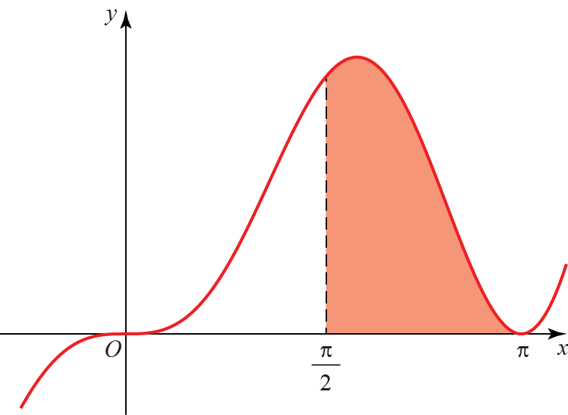

**2** The diagram shows the curve with equation

**Figure 2**

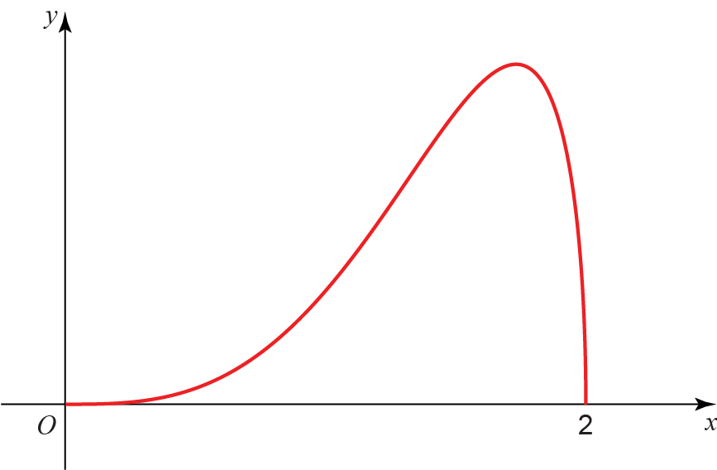

**a** Complete the table with the value of *y* corresponding to *x* = 1.5. Give your answer correct to 5 decimal places. **(1 )**

|  |  |  |  |  |  |
| --- | --- | --- | --- | --- | --- |
| ***x*** | 0 | 0.5 | 1 | 1.5 | 2 |
| ***y*** | 0 | 0.12103 | 0.86603 |  | 0 |

Given that

**b** Use the trapezium rule with 4 equal width strips to find an approximate value of *I*,   
giving your answer to 4 significant figures. **(3 )**

**c** By using an appropriate substitution, or otherwise, find the exact value of, leaving your answer as a rational number in its simplest form. **(6 )**

**d** Suggest one way in which your estimate using a trapezium rule could be improved. **(1 )**

**3** 

**a** Given that , find the values of the constants *A* and *B*. **(5 )**

**b** Find the exact value of **(5 )**

**4** The value of a computer, *V*, decreases over time, *t*, measured in years. The rate of decrease of the value is proportional to the remaining value.

**a** Given that the initial value of the computer is *V*0 , show that **(4 )**

After 10 years the value of the computer is

**b** Find the exact value of *k*. **(3 )**

**c** How old is the computer when its value is only 5% of its original value? Give your answer to 3 significant figures. **(3 )**

**5** A large cylindrical tank has radius 40 m. Water flows into the cylinder from a pipe at a rate of 4000π m3 min−1. At time *t*, the depth of water in the tank is *h* m. Water leaves the bottom of the tank through another pipe at a rate of 50π*h* m3 min−1.

**a** Show that *t* minutes after water begins to flow out of the bottom of the cylinder,  **(6 )**

**b** When *t* = 0 min, *h* = 50 m. Find the exact value of *t* when *h* = 60 m. **(6 )**

**Vectors**

**1** **a** The coordinates of *A* and *B* are (−1, 7, *k*) and (4, 1, 10) respectively. Given that the distance from *A* to *B* is units, find the possible values of the constant *k*. **(3 )**

**b** For the larger value of *k*, findthe unit vector in the direction of . **(3 )**

**2** A triangle has vertices *A*(−2, 0, −4), *B*(−2, 4, −6) and *C*(3, 4, 4). By considering the side lengths of the triangle, show that the triangle is a right-angled triangle. **(6 )**

**3** Find the angle that the vectormakes with the positive *y*-axis. **(3 )**

**4 a** Show that inwithand,

to one decimal place. **(7 )**

**b** Hence findand. **(3 )**

**5** Given that, find the values of *a*, *b* and *c*. **(6 )**

**6** A particle of mass 3 kg is acted on by three forces,, and.

**a** Find the resultant force *R* acting on the particle. **(2 )**

**b** Find the acceleration of the particle, giving your answer in the form **(2 )**

**c** Find the magnitude of the acceleration. **(2 )**

**d** Given that the particle starts at rest, find the exact distance travelled by the particle in the first 10 s. **(3 )**

**7** The diagram shows a cuboid whose vertices are *O*, *A*, *B*, *C*, *D*, *E*, *F* and *G*. **a**, **b** and **c** are the vectors ,  and  respectively. The points *M* and *N* lie on *OA* such that . The points *K* and *L* lie on *EF* such that 

**Figure 1**

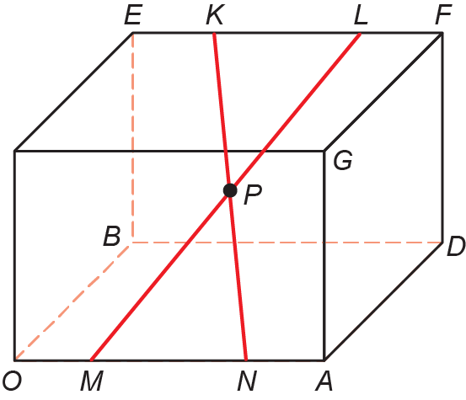

Prove that the diagonals *KN* and *ML* bisect each other at *P*. **(10 )**