Year 13 Applied Maths Homework Booklet
Name:____________________________________
Maths Teachers:____________________________

Contents
Page 2: Regression and Correlation
Page 13: Probability
Page 17: The normal distribution
Page 24: Moments
Page 28: Forces at an Angle
Page 32: Applications of Kinematics
Page 36: Applications of Forces
Page 41: Further Kinematics

Regression and Correlation
1 The table shows some data collected on the temperature, in °C, of a cup of coffee, c, and the time, t in minutes, after which it was made.

t | 0 | 2 | 4 | 5 | 7 | 11 | 13 | 17 | 25
c | 81.9 | 75.9 | 70.1 | 65.1 | 60.9 | 51.9 | 50.8 | 45.1 | 39.2

The data is coded using the changes of variable x = t and y = log₁₀ c.
The regression line of y on x is found to be y = 1.89 − 0.0131x.
a Given that the data can be modelled by an equation of the form c = ab^{t} where a and b are constants, find the values of a and b. (3 marks)
b Give an interpretation of the constant b in this equation. (1 mark)
c Explain why this model is not reliable for estimating the temperature of the coffee after an hour. (1 mark)

2 The number of bacteria, n thousand per cm³, in a sample of liquid is measured over a period of time, t, in hours. The data is shown in the table.

t | 3.9 | 5.5 | 6.8 | 8.5 | 10.6 | 11.5 | 13.3 | 14.7 | 16.5 | 17.8
n | 10.1 | 13.1 | 14.6 | 20.7 | 27.9 | 31.5 | 40 | 49.9 | 64.7 | 75.6

The data is coded using the changes of variable x = t and y = log₁₀ n.
The regression line of y on x is found to be y = 0.7606 + 0.0635x.
a Given that the data can be modelled by an equation of the form n = ab^{t} where a and b are constants, find the values of a and b. (3 marks)
b Give an interpretation of the constant a in this equation. (1 mark)
c Explain why this model is not reliable for estimating the number of bacteria after 24 hours. (1 mark)

3 The data and scatter diagram show the population, p, in millions, of a country taken t years since their first census.

t | 0 | 10 | 20 | 30 | 40 | 50 | 60 | 70 | 80 | 90 | 100
p | 238.4 | 252.1 | 251.3 | 279 | 318.7 | 361.1 | 439.2 | 548.2 | 683.3 | 846.4 | 1028.7

Figure 1
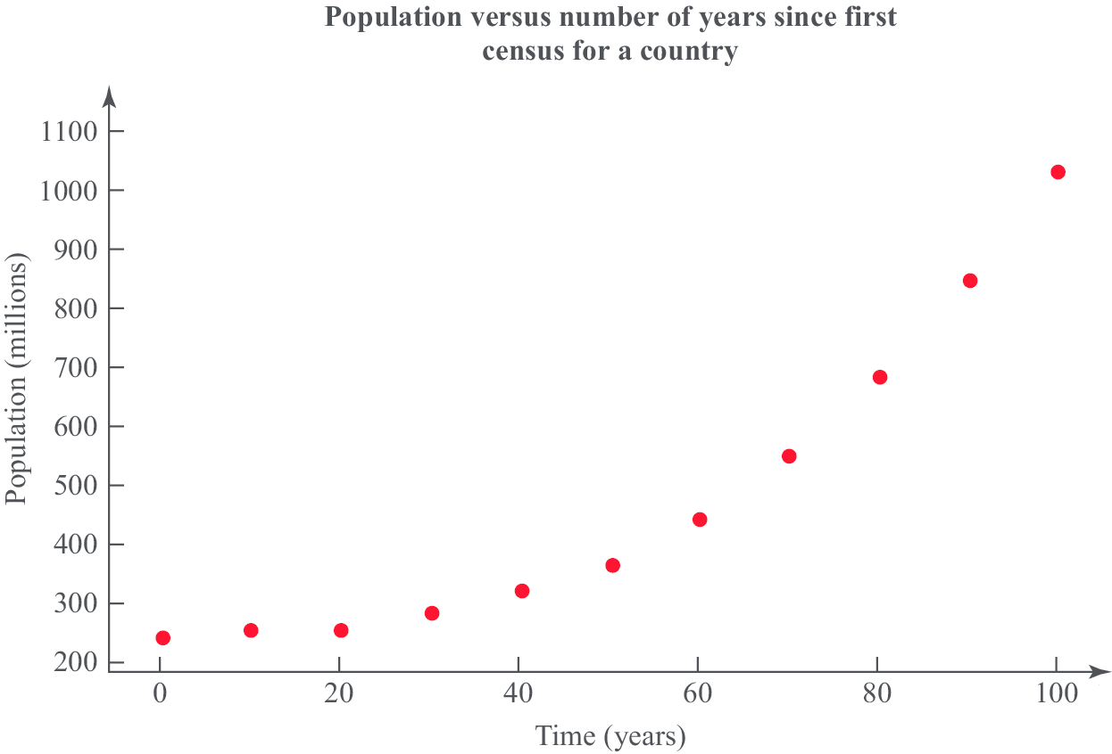

a Give a reason why the data is coded using the changes of variable x = t and y = log₁₀ p. (1 mark)
b The product moment correlation coefficient for the coded data is r = 0.9735. Comment on r for this model. (2 marks)
c With reference to your answer to part b, state whether a model in the form p = ab^{t}, where a and b are constants, is a good fit for this data. (2 marks)

4 The data and scatter diagram show the weight of chickens, x kilograms, and the average weight, y grams, of eggs laid by a random sample of 10 chickens.

Weight of chickens (kg) | 2.9 | 1.9 | 1.6 | 2.7 | 3.1 | 2.2 | 2.7 | 1.9 | 1.7 | 2.6
Average weight of eggs (g) | 58 | 56 | 55 | 66 | 47 | 63 | 49 | 56 | 53 | 53

Figure 2
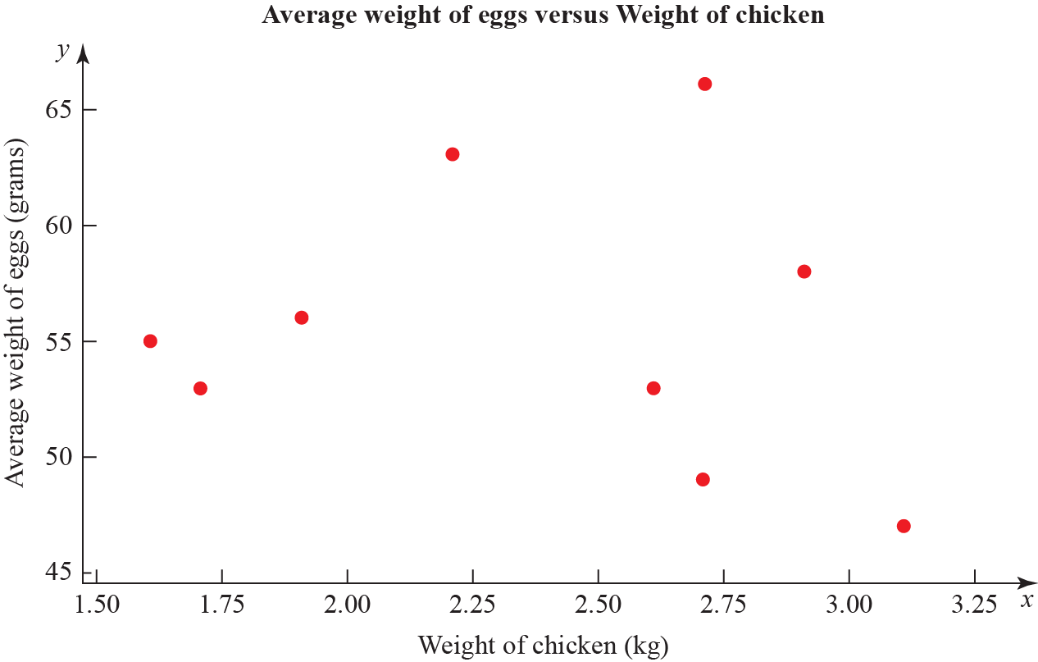

The product moment correlation coefficient for the average weight of eggs and weight of chickens is −0.136.
a Test for evidence of a negative population product moment correlation coefficient at the 2.5% significance level. Interpret this result in context. (3 marks)
b Explain why even if the population product moment correlation coefficient between two variables is close to zero there may still be a relationship between them. (2 marks)

5 A researcher wishes to investigate if there is a positive correlation between the number of vehicles and the number of road fatalities in European countries.
He selects a random sample of 10 European countries and records the number of vehicles, v per 1000 people, and the number of road fatalities, r per 100 000 population, for a particular year. These are shown in the table and scatter diagrams.

Country | v | r
Austria | 578 | 5.4
Belgium | 559 | 6.7
France | 578 | 5.1
Germany | 572 | 4.3
Greece | 624 | 9.1
Ireland | 513 | 4.1
Italy | 679 | 6.1
Luxembourg | 739 | 8.7
Spain | 593 | 3.7
UK | 519 | 2.9
Figure 3
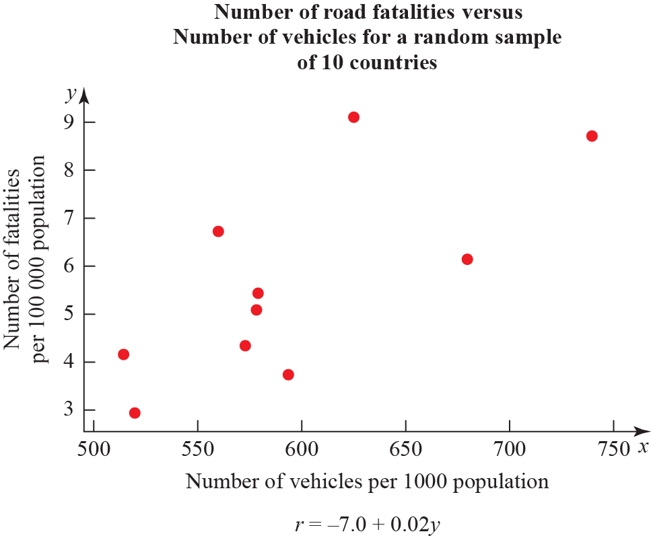
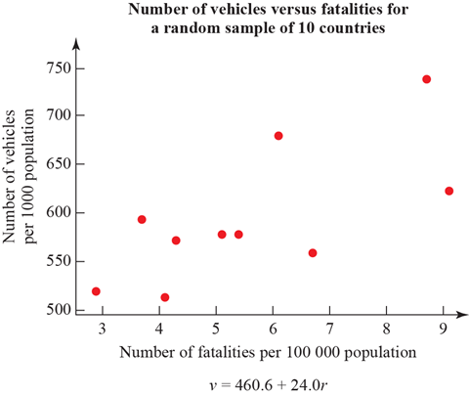

a What is the definition of a critical value? (1 mark)
b The product moment correlaton coefficient for v and r is 0.714. Use this value to test for positive correlation at the 5% significance level. Interpret your result in context. (3 marks)
c The researcher wishes to predict the number of road fatalities for a country with 650 vehicles per 1000 people. Write down the regression model he should use. (1 mark)
d State the dependent variable for the regression model in part c. (1 mark)
e Monaco has 899 vehicles per 1000 people. Explain why the model stated in c is not reliable for estimating the number of road fatalities in Monaco. (1 mark)

6 An engineer believes that there is a relationship between the CO₂ emissions and fuel consumption for cars.
A random sample of 40 different car models (old and new) was taken and the CO₂ emission figures, e grams per kilometre, and fuel consumption, f miles per gallon, were recorded.
The engineer calculates the product moment correlation coefficient for the 40 cars and obtains r = −0.803.
Figure 4
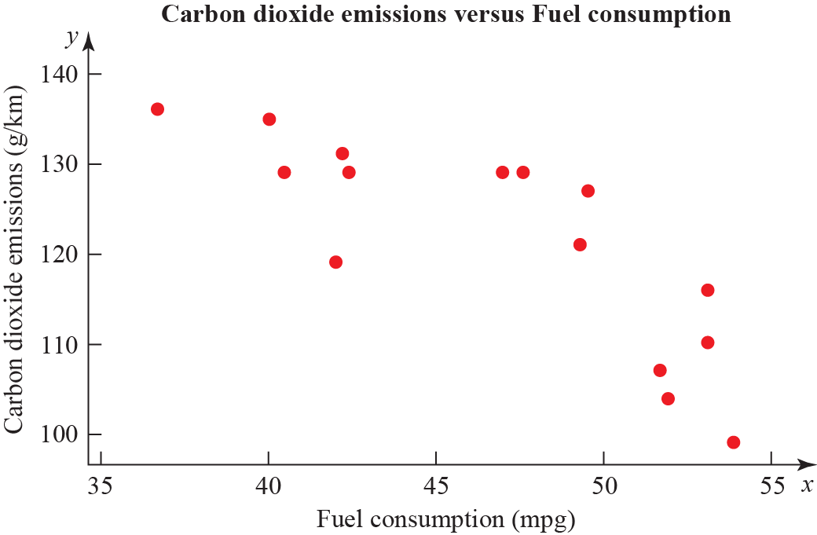

a State what is measured by the product moment correlation coefficient. (1 mark)
b State, with a reason, whether a linear regression model based on these data is reliable or not for a car when the fuel consumption is 60 mpg. (1 mark)
c For the linear regression model e = 198 − 1.71 × f write down the explanatory variable. (1 mark)
d State the definition of a hypothesis test. (1 mark)
e Test at 1% significance level whether or not the product moment correlation coefficient for CO₂ emissions and fuel consumption is less than zero. State your hypotheses clearly. (3 marks)

7 To investigate if there is a correlation between daily mean temperature (ºC) and daily mean pressure (hPa) the location Hurn 2015 was randomly selected from:
Camborne 2015 Camborne 1987
Hurn 2015 Hurn 1987
Leuchars 2015 Leuchars 1987
Leeming 2015 Leeming 1987
Heathrow 2015 Heathrow 1987
Source: Pearson Edexcel GCE AS and AL Mathematics data set

a State the definition of a test statistic. (1 mark)
b The product moment correlation coefficient between daily mean temperature and daily mean pressure for these data is −0.258 with a p-value of 0.001. Use a 5% significance level to test whether or not there is evidence of a correlation between the daily mean temperature and daily mean pressure. (3 marks)
c The scatter diagram shows daily mean temperature versus daily mean pressure, by season, for Hurn 2015. Give two interpretations on the split of the data between summer and autumn. (2 marks)
Figure 5
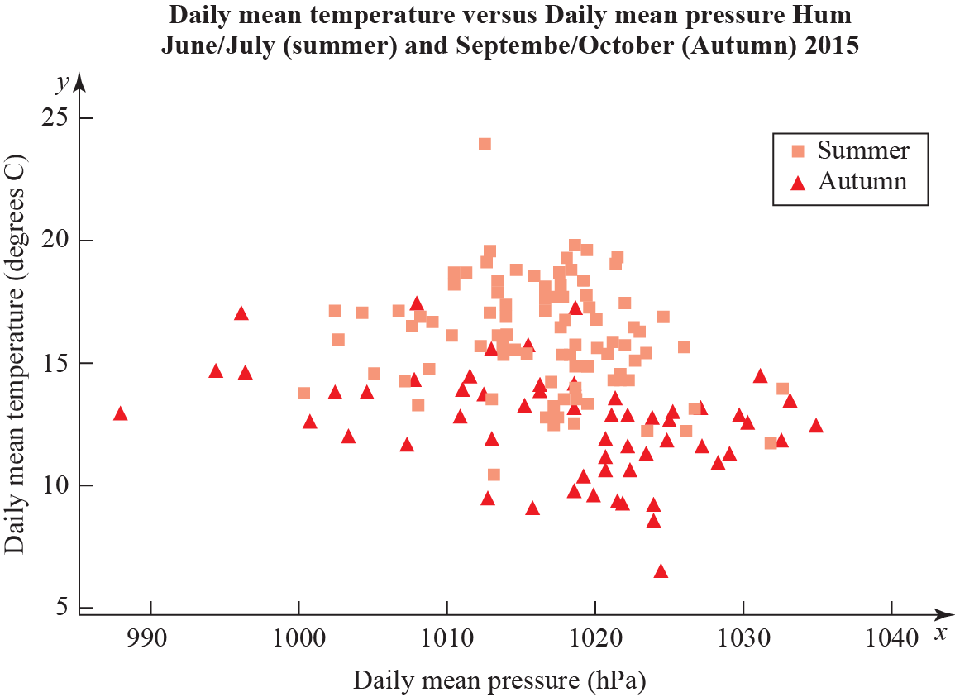

8 To investigate if there is a correlation between daily mean pressure (hPa) and daily mean wind speed (kn) the location Hurn 2015 was randomly selected from:
Camborne 2015 Camborne 1987
Hurn 2015 Hurn 1987
Leuchars 2015 Leuchars 1987
Leeming 2015 Leeming 1987
Heathrow 2015 Heathrow 1987.
Source: Pearson Edexcel GCE AS and AL Mathematics data set
The statistical software output for these data is shown below.

Figure 6
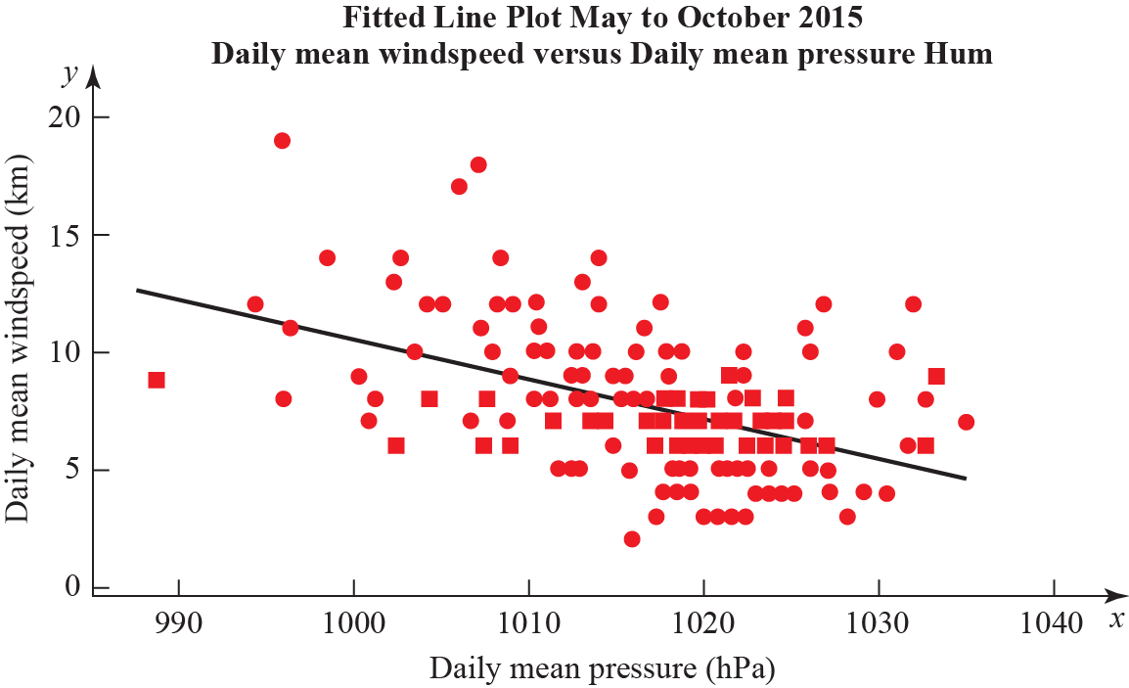

Correlation coefficient
Daily mean winds and Daily mean pressure = −0.477 p-value < 0.001
Regression summary output for daily mean wind speed versus daily mean pressure

 | Coefficients | Lower 95% | Upper 95%
Intercept | 180.00 | 133.5424 | 226.4128
Daily Mean Pressure(hPa)  Gradient | −0.1694 | −0.21512 | −0.12377

a State what is measured by the product moment correlation coefficient. (1 mark)
b Comment on the correlation between the two variables. (1 mark)
c Give an interpretation of the correlation between the two variables. (1 mark)
d Test at 5% significance level whether or not the product moment correlation coefficient for the population is less than zero. State your hypotheses clearly. (3 marks)
e Write down the regression model for daily mean wind speed versus daily mean pressure. (2 marks)
f Interpret the gradient of the line of regression stated in part e. (1 mark)
g The regression model (equation of regression) was used to predict the daily mean wind speed of 11.15 knots for a daily mean pressure of 995 hPa. Comment on the accuracy of this prediction. (1 mark)

Probability
1 The table below shows the number of gold, silver and bronze medals won by two teams in an athletics competition.

 | Gold | Silver | Bronze
Team A | 29 | 17 | 18
Team C | 21 | 23 | 17

The events G, S and B are that a medal is gold, silver or bronze respectively. Let A be the event that team A won a medal and C team C won a medal. A medal winner is selected at random. Find
a P(G) (2 marks)
b P([AS]') (2 marks)
c Explain, showing your working, whether or not events S and A are statistically independent. Give reasons for your answer. (2 marks)
d Determine whether or not events B and C are mutually exclusive. Give a reason for your answer. (2 marks)
e Given that 30% of the gold medal winners are female, 60% of the silver medal winners are female and 40% of the bronze medal winners are female, find the probability that a randomly selected medal winner is female. (2 marks)

2 A mechanic carried out a survey on the defects of cars he was servicing. He found that the probability of a car needing a new tyre is 0.33 and that a car needing a new tyre has a probability of 0.7 of needing tracking. A car not needing a new tyre has a probability of 0.04 of needing tracking.
a Draw a tree diagram to represent this information. (3 marks)
b Find the probability that a randomly chosen car has exactly one of the two defects, needing a new tyre or needing tracking. (2 marks)
The mechanic also finds that cars need new brake pads with probability 0.35 and that this is independent of needing new tyres or tracking. A car is chosen at random.
c Find the probability that the car has at least one of these three defects. (2 marks)
d What advice would you give to motorists? (1 mark)

3 P(E) = 0.25, P(F) = 0.4 and P(EF) = 0.12
a Find P(E'|F') (2 marks)
b Explain, showing your working, whether or not E and F are statistically independent. Give reasons for your answer. (2 marks)
The event G has P(G) = 0.15
The events E and G are mutually exclusive and the events F and G are independent.
c Draw a Venn diagram to illustrate the events E, F and G, giving the probabilities for each region. (5 marks)
d Find P([FG]') (2 marks)

4 In a factory, three machinists, Amy, Brad and Ceri, are used to sew shirts.
Amy sews 40% of the shirts.
Brad sews 35% of the shirts.
Ceri sews the rest of the shirts.
It is known that 5% of the shirts sewn by Amy are faulty, 2% of the shirts sewn by Brad are faulty and 3% of the shirts sewn by Ceri are faulty.
a Draw a tree diagram to illustrate all the possible outcomes and associated probabilities. (3 marks)
A shirt is selected at random.
b Calculate the probability that the shirt is sewn by Brad and is not faulty. (2 marks)
c Calculate the probability that the shirt is faulty. (2 marks)
d Given that the shirt is faulty, find the probability that it was not sewn by Ceri. (3 marks)

5 A group of students were surveyed by a principal andwere found to always hand in assignments on time. When questioned about their assignmentssaid they always start their assignments on the day they are issued and, of those who always start their assignments on the day they are issued,hand them in on time.
a Draw a tree diagram to represent this information. (3 marks)
b Find the probability that a randomly selected student:
i always start their assignments on the day they are issued and hand them in on time. (2 marks)
ii does not always hand in assignments on time and does not start their assignments on the day they are issued. (4 marks)
c Determine whether or not always starting assignments on the day they are issued and handing them in on time are statistically independent. Give reasons for your answer. (2 marks)

The normal distribution
1 The distributions for the heights for a sample of females and males at a UK university can be modelled using normal distributions with mean 165 cm, standard deviation 9 cm and mean 178 cm, standard deviation 10 cm respectively.
A female’s height of 177 cm and a male’s height of 190 cm are both 12 cm above their means. By calculating z-values, or otherwise, explain which is relatively taller. (4 marks)

2 A certain type of cabbage has a mass M which is normally distributed with mean 900 g and standard deviation 100 g.
a Find P(M < 850) (1 mark)
10% of the cabbages are too light and 10% are too heavy to be packaged and sold at a fixed price.
b Find the minimum and maximum weights of the cabbages that are packaged. (3 marks)

3 In a town, 54% of the residents are female and 46% are male. A random sample of 200 residents is chosen from the town. Using a suitable approximation, find the probability that more than half the sample are female. (6 marks)

4 The heights of a population of men are normally distributed with mean μ cm and standard deviation σ cm. It is known that 20% of the men are taller than 180 cm and 5% are shorter than 170 cm.
a Sketch a diagram to show the distribution of heights represented by this information. (3 marks)
b Find the value of μ and σ. (7 marks)
c Three men are selected at random, find the probability that they are all taller than 175 cm. (2 marks)

5 a State the conditions under which the normal distribution may be used as an appoximation to the binomial distribution X ~ B(n, p). (2 marks)
b Write down the mean and variance of the normal approximation to X in terms of n and p. (2 marks)
A manufacturer claims that more than 55% of its batteries last for at least 15 hours of continuous use.
c Write down a reason why the manufacturer should not justify their claim by testing all the batteries they produce. (1 mark)
To test the manufacturer’s claim, a random sample of 300 batteries were tested.
d State the hypotheses for a one-tailed test of the manufacturer’s claim. (1 mark)
e Given that 184 of the 300 batteries lasted for at least 15 hours of continuous use a normal approximation to test, at the 5% level of significance, whether or not the manufacturer’s claim is justified. (7 marks)
6 The summary statistics and histogram are an extract from statistical software output for the distribution of the daily mean pressure for Beijing, May to August (inclusive) 2015.
Figure 1
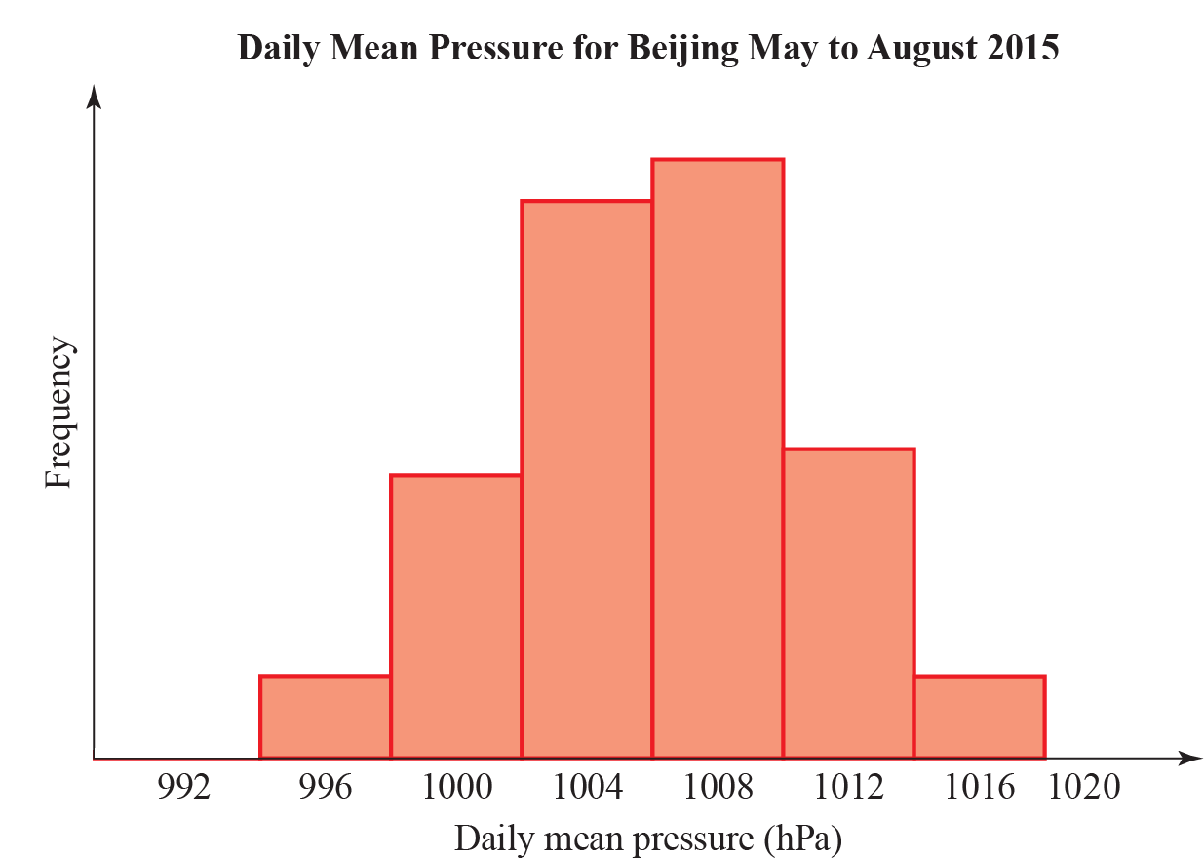

Variable | N | Mean | Standard deviation | Q₁ | Q₂ | Q₃
Daily Mean Pressure | 123 | 1006 | 4.4 | 1003 | 1006 | 1010

a Explain why it is reasonable to model the daily mean pressure for Beijing, during May to August using a normal distribution. (1 mark)
The distribution for the daily mean pressure for Beijing, May to August 2015, X, can be modelled by a normal distribution.

Daily mean pressure (hPa) | Suggests
Above 1013 | Good weather
Between 1013 and 1000 | Fair weather
Less than 1000 | Poor or bad weather
Less than 980 | Hurricane

b Based on the statistical output and the information in the table above, what is the chance of poor or bad weather in Beijing during May to August? (2 marks)

c Although very unlikely, based on the model in part a, give a reason why we cannot say there is no chance of a hurricane in Beijing during May to August. (1 mark)
The distribution for daily mean pressure for Jacksonville during May to August can also be considered normally distributed with mean 1017 hPa and standard deviation 3.26 hPa. A student claims that you can depend on better weather in Jacksonville than in Beijing during May to August.
d State, giving reasons, whether the information in this question supports this claim. (4 marks)

7 The mean body temperature for women is normally distributed with mean 36.73°C with variance 0.1482 (°C)². Kay has a temperature of 38.1°C.
a Calculate the probability of a woman having a temperature greater than 38.1°C. (2 marks)
b Advise whether should Kay get medical advice. Give a reason for your advice. (1 mark)

Moments
1 A light see-saw is 10 m long with the pivot 3 m from the left.
Figure 1
a A 4 kg weight is placed on the left-hand end of the see-saw. Write down the anticlockwise moment about the pivot. (3 marks)
b A force of magnitude F N is applied to the right-hand end of the see-saw. The force acts vertically downwards. Write down the clockwise moment about the pivot due to this weight. (1 )
c Find the value of F for which the system is in equilibrium. (3 )

2 Alice, who weighs 50 kg, sits on the right-hand end of a light see-saw. Bob, who weighs 80 kg, stands on the opposite side at a distance x m from the end. The length of the see-saw is 4 m and it pivots about its centre.
Figure 2
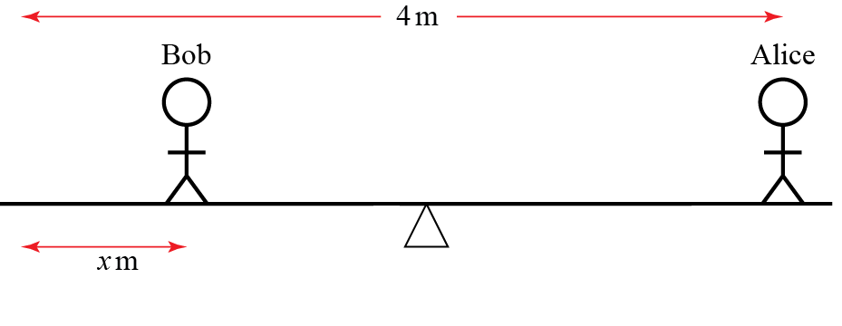

a Draw a diagram showing the forces acting on the see-saw due to the two people. Label the value of each force in newtons (2 )
b Write down the total clockwise moment about the centre in terms of x. (5 )
c Find the value of x for which the see-saw is in equilibrium. (2 )
d Given that Bob remains on the opposite side to Alice, describe with inequalities the range of x for which the see-saw tilts towards Alice. (2 )
e Describe one limitation of this model. (1 )

3 A 5000 kg bus hangs 12 m over the edge of a cliff and has 1000 kg of gold at the front. The gold sits on a wheeled cart. A group of n people, each weighing 70 kg, stands at the other end. The bus is 20 m long.
Figure 3
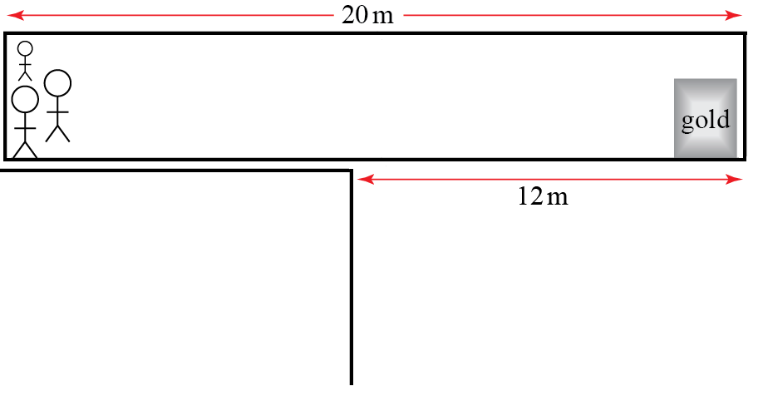
a Write down the total clockwise moment about the cliff edge in terms of n. (7 )
b Find the smallest number of people needed to stop the bus falling over the cliff. (2 )
c One person needs to walk to the end of the bus to retrieve the gold. Find the smallest number of people needed to stop the bus falling over the cliff in this situation, including the one retrieving the gold. (4 )

4 Two interlocking gears are in equilibrium. The gear on the right has a radius of 10 cm and has a loop 8 cm from the centre. The loop is to the right of, and level with the centre of the gear. A 10 kg mass hangs from the loop. The other gear has a radius of 5 cm and a loop 2 cm from the centre. The loop is to the left of, and level with the centre of the gear. A mass M kg hangs from the left loop.
Figure 4
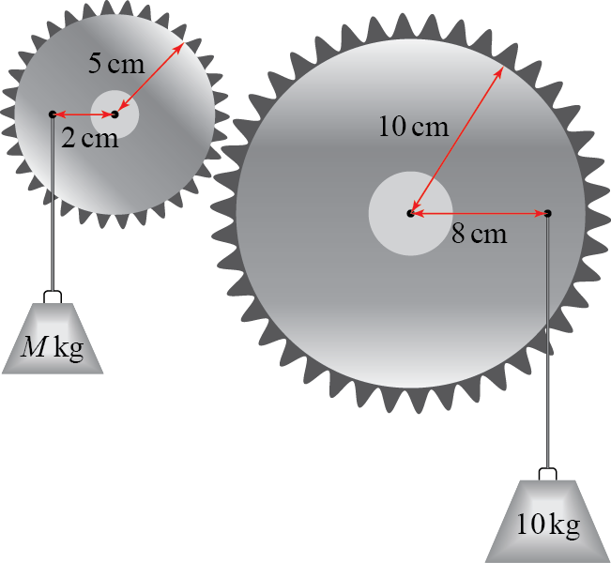
Find the value of M. (10 )

5 Two identical 5 m light see-saws are joined at their ends. Robert, who weighs 80 kg, stands on top of the joint. The distance between Robert and each of the pivots is 2 m. Poppy and Quentin stand on the two remaining ends of the see-saws. Poppy weighs p kg and Quentin weighs q kg. The system is in equilibrium.
Figure 5
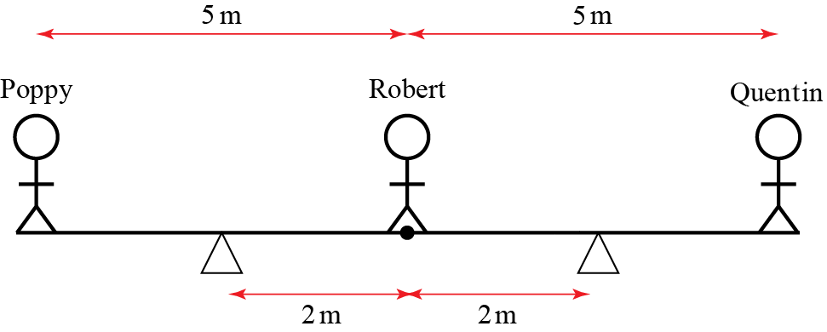
Show that, to the nearest whole number, p + q = 53 (8 )

Forces at an Angle
1 An object rests on a rough surface and is pushed horizontally with force of 6 N. The mass of the object is 5 kg and the coefficient of friction between the object and the surface is 0.3.
a Draw a diagram showing all the forces acting on the object. Describe each of the forces using words and calculate their values. (6 )
b The horizontal force acting on the object is increased to P N. Find the largest value of P for which the object does not slip. (3 )

2 An object has three different forces F₁ N, F₂ N and F₃ N acting on its centre of mass.
F₁and. The object is in equilibrium. Find F₃. (3 )

3 An object resting on a rough surface is attached to a rope angled at 30° to the horizontal. The rope is pulled with a force of P N. The mass of the object is 5 kg.
Figure 1
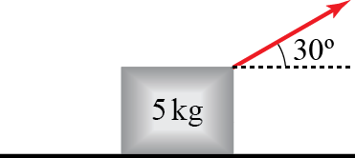
a Draw a diagram showing all the forces acting on the object. Describe the origin of each force using words. (4 )
b By resolving forces in the horizontal and vertical directions, calculate the magnitude of each force in the diagram, giving your answers in terms of P where appropriate. (4 )
c If P = 20, the object does not slip. Use this information to give a bound on $μ$ in the form of an inequality. (6 )

4 A cylindrical object with mass 8 kg rests on two cylindrical bars of equal radius. The lines connecting the centre of each of the bars to the centre of the object make an angle of 40° to the vertical.
Figure 2
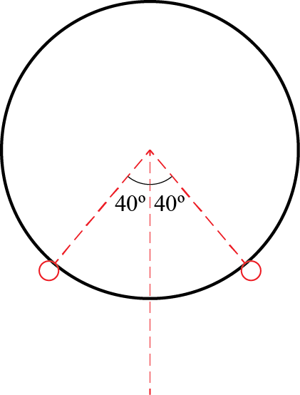
a Draw a diagram showing all the forces acting on the object. Describe each of the forces using words. (2 )
b Calculate the magnitude of the force on each of the bars due to the cylindrical object. (7 )

5 An object of 3 kg sits on a plane inclined at an angle θ to the horizontal. The coefficient of friction between the object and the plane is μ. The system is in limiting equilibrium.
Figure 3
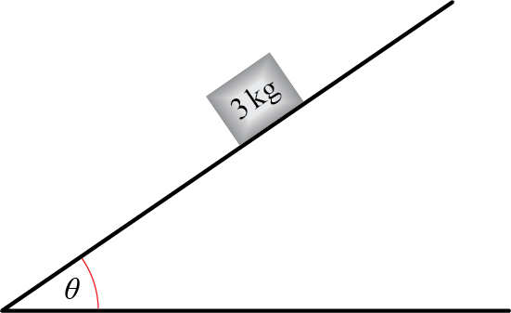

a Draw a diagram showing all the forces acting on the object. Describe the origin of each force using words. (3 )
b By resolving forces in two perpendicular directions, show that. (6 )
c Hence, determine whether or not the object slips if μ = 0.3 and θ = 30°. (4 )
d As θ approaches $90°$, state whether an object of any mass could remain in equilibrium. Explain your answer. (2 )

Applications of Kinematics
1 A ball is launched from the origin with speed 1 m s⁻¹. Its velocity vector makes an angle above the horizontal. It travels over flat ground and is modelled as a particle moving freely under gravity. (In this question, take g = 10 m s⁻²)
Figure 1
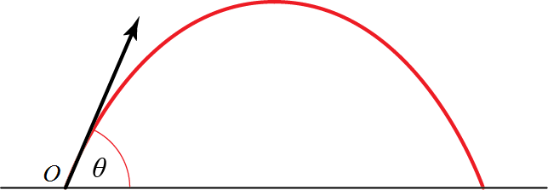

a Find the horizontal and vertical displacements of the particle at time t seconds. You should give your answer in terms of θ and t. (4 )
b Show that the horizontal distance travelled by the particle before it hits the ground is. (5 )
c Find the value θ for which the horizontal distance travelled is a maximum. (2 )
d Describe one limitation of this model. (1 )

2 A ball, modelled as a particle moving freely under gravity, is launched at 2 m s⁻¹ from the origin at angle 45° above the horizontal.
(In this question, take g = 10 m s⁻²)
a Find the coordinates of the particle when it is at its maximum height. (10 )
On another occasion, the projectile is again is launched at 2 m s⁻¹ from the origin at angle 45° above the horizontal. It travels a horizontal distance d m before hitting a vertical wall and then falling straight to the ground.
Figure 2
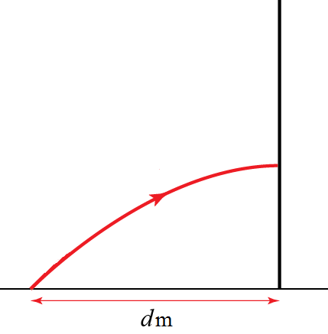
b Find the maximum height attained if d = 0.1. Give your answer in cm. (5 )
c Describe a possible limitation of this model. (1 )

3 A projectile is launched at 8 m s⁻¹ from the origin at a 60° angle to the horizontal. Find the length of time for which the particle is at least 2 m above its launch point. (In this question, take g = 9.8 m s⁻²) (8 )

4 An archer shoots an arrow at 10 m s⁻¹ from the origin and hits a target at (10, −5) m. The initial velocity of the arrow is at an angle θ above the horizontal. The arrow is modelled as a particle moving freely under gravity.
(In this question, take g = 10 m s⁻²)
a Show that (tan θ − 1)² = 1 (11 )
b Find the possible values of $θ$. (3 )

Applications of Forces
1 A 10 m long, uniform ladder has a mass of 6 kg and makes an angle of 20° with a smooth vertical wall. It stands on a rough horiztonal floor, which has coefficient of friction 0.3 with the bottom of the ladder.
Figure 1
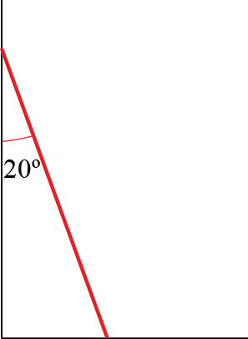

a Draw a diagram showing all the forces acting on the ladder. Describe the origin of each force using words. (4 )
b Calculate the magnitude of each force and hence determine whether or not the ladder slips. (13 )

2 Three forces, F₁, F₂ and F₃, act on a circular lamina of radius 5 cm. The origin is at the centre of the lamina.
The net force on the lamina is zero.
a Find the value of $f$. (2 )
b Find the total moment about the origin. Give your answer in N m. (4 )

3 A 0.1 kg inflatable ball floats on the surface of the sea. The current from the water underneath the ball exerts a force and the wind exerts a force ofon the ball.
a Find the resultant force exerted on the ball. (2 )
b Calculate the acceleration of the ball. (3 )
Initially, the ball is at the origin and has velocitym s⁻¹.
c Find the x and y coordinates of the ball t s later. (4 )
d Find the distance travelled by the ball when t = 10 s. (5 )

4 A 0.5 kg particle experiences two forces,and Initially, the particle is at rest and has position vector
a Find the x and y coordinates of the particle t seconds later. (9 )
b Explain why the particle never returns to its starting point. (2 )
c Describe a physical situation which this mathematical model could represent and give physical meanings to A and B. (2 )

Further Kinematics
1 The position of a particle is r metres. Initially r = i. The velocity of the particle at time t seconds is v m s⁻¹ where v = t i + 3t^{2̴} j
a Find r in terms of t. (3 )
b Find the acceleration of the particle when t = 4. (4 )
c Find the position of the particle when it is 1 m from the x-axis. (2 )

2 The position, r, of a planet orbiting a star at time t is given by
a Find the velocity v and acceleration a of the planet in terms of t. (3 )
b Show that a = −4r. (1 )
c Sketch the trajectory of the particle and draw arrows showing its velocity and acceleration when t = 0. (2 )

3 A ball falling vertically through viscous fluid is subject to a drag force of magnitude kv N, where v m s⁻¹ is the speed of the ball at time t seconds. The mass of the ball is 1 kg.
a Draw a force diagram showing the forces on the ball. (2 )
b Find an expression for v when the ball is in equilibrium. (2 )
c Explain why (3 )
d Show, by substitution, that satisfies this equation in part c. (3 )
e Explain why this solution agrees with your answer to part b. (1 )
f Describe one limitation of this model. (1 )

4 A car travels along a long, straight road for one hour, starting from rest.
After t hours, its acceleration is a km h⁻², where a = 180 − 360t.
a Find the speed of the car, in km h⁻¹ in terms of t. (2 )
The speed limit is 40 km h⁻¹.
b Find the range of times during which the car is breaking the speed limit. Give your answer in minutes. (4 )
c Find the average speed of the car over the whole journey. (5 )

5 At time t seconds, a 2 kg particle experiences a force F N, where
a Find the acceleration of the particle at time t seconds. (3 )
The particle is initially at rest at the origin.
b Find the position of the particle at time t seconds. (6 )
c Find the particle’s velocity when t = 1. (3 )

