Y8 DECEMBER
ASSESSMENT
Section B
Calculator
Time allowed: 28 mins

Name:……………………… Form:……

Maths Teacher:……………………………..

10 A wheel has a diameter of 70 cm. Work out its circumference.

….…………………cm
(2 marks)
11 A circle fits exactly inside a square as shown.
The square has sides of length 10 cm.
a Work out the area of the circle.

……………………cm²
b Work out the area shaded grey.

…………………………cm²
(4 marks)

12. Find the missing lengths of the triangles below.
5cm 6cm
3cm a
4cm b 15cm 11cm c

(9 marks)

13. A triangle has sides with lengths of 5 metres, 8 metres and 10 metres. Is it a right angled triangle? Explain your reasoning. (2 marks)

14. To wash a window that is 9 metres off the ground, Ben leans a 15 metre ladder against the side of the building. To reach the window, how far from the building should Ben place the base of the ladder? (3 marks)

15 A rectangle has length 5 cm and width 12 cm. Work out the length of the diagonal of the rectangle.

…………………………cm
(2 marks)
16 The cross-section of a prism is in the shape of a trapezium as shown.
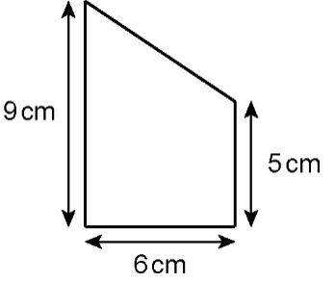
The volume of the prism is 630 cm³. Work out its length.

………………………cm
(3 marks)

17 A water bottle in the shape of a cylinder holds 1 litre of water when full. Its height is 15 cm.
Work out the radius of the water bottle. (1 litre = 1000 cm³)

………………………cm
(3 marks)

18 This graph shows the change of depth, d, of water against time, t, as a container is filled at a constant rate.
d
t

Which of these is the container?
Circle the correct letter.
[1 mark]

A
B
C
D

19 Here is a conversion graph between two units of pressure.
Bars
PSI
60
40
1
0
20
3
2
0

19 (a) A car tyre needs to be at a pressure of 30 psi.

What is this in Bars?
[1 mark]
Answer
19 (b) A racing bicycle has a recommended pressure of 7.5 Bars.

What is this in psi?
[2 marks]
Answer

20 Water is poured into this container at a constant rate until it reaches the dashed line.

One of these graphs shows the change of the depth, d, of water against time, t.
Circle the correct letter.
[1 mark]

d
t
d
t
d
t
d
t
A
B
C
D

