**Year 12 Pure Maths Homework Booklet**

**Name:____________________________________**

**Maths Teachers:____________________________**

**Contents**

**Page 2:** Algebraic Expressions

**Page 5:** Quadratics

**Page 10:** Equations and Inequalities

**Page 15:** Graphs and Transformations

**Page 20:** Straight Line Graphs

**Page 26:** Circles

**Page 30:** Algebraic Methods

**Page 34:** The Binomial Expansion

**Page 37:** Trigonometric Ratios

**Page 41:** Trigonometric Identities and Equations

**Page 45:** Vectors

**Page 48:** Differentiation

**Page 54:** Integration

**Page 58:** Exponentials and Logarithms

**Algebraic Expressions**

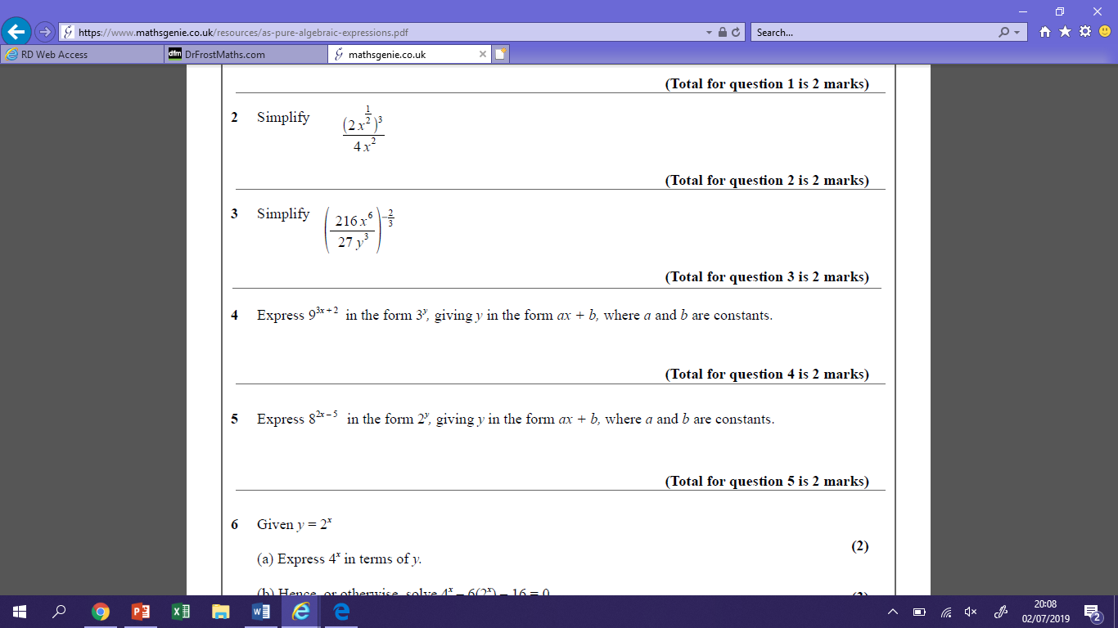**Practicing the Technique**

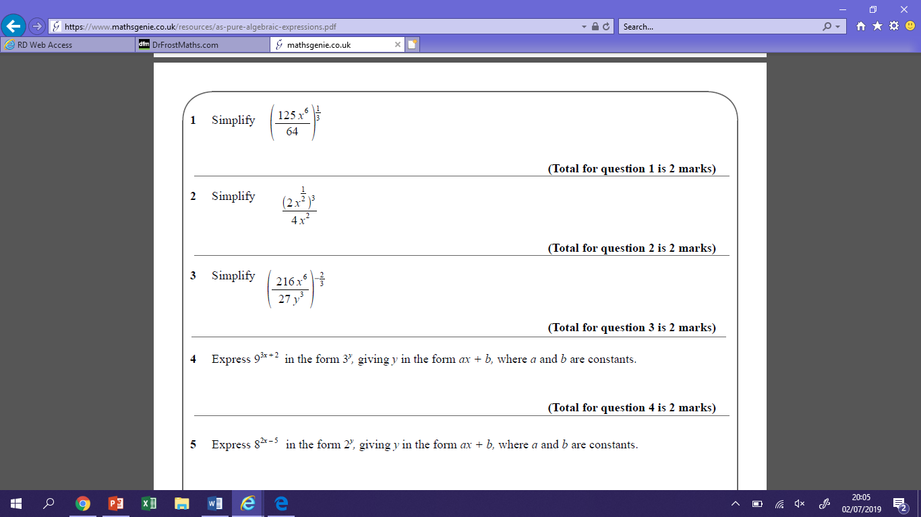 **2**

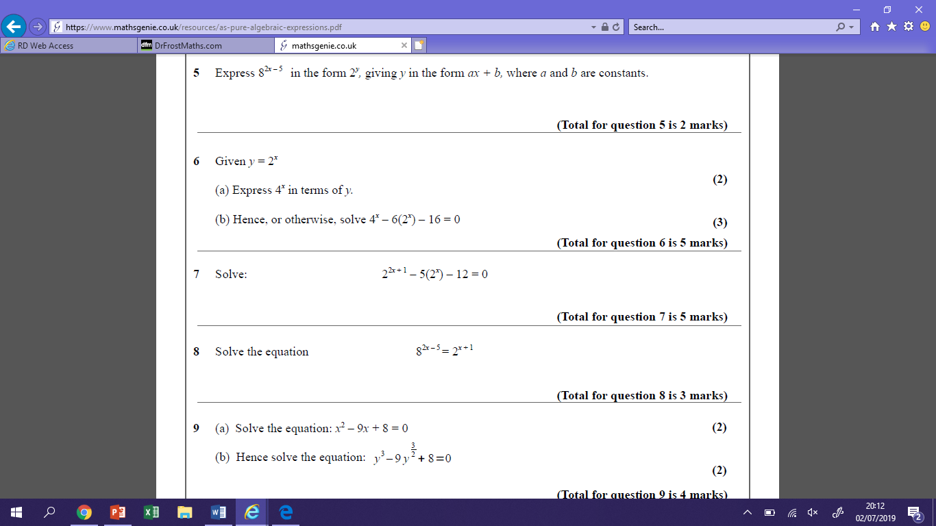**3**

**4** 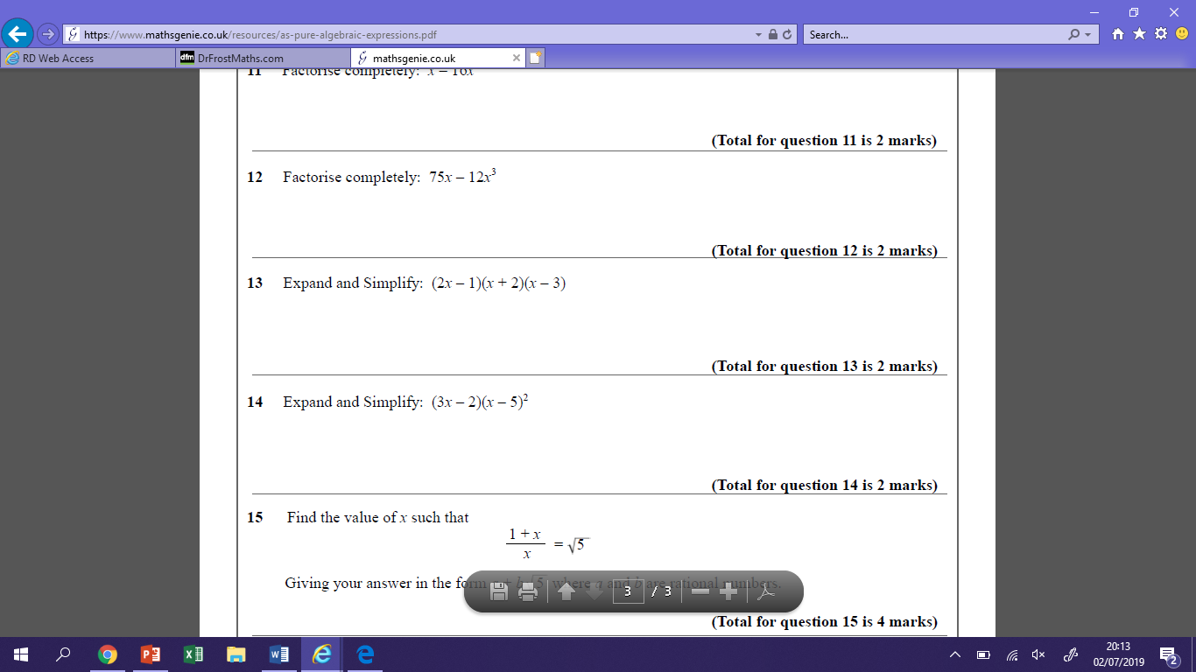

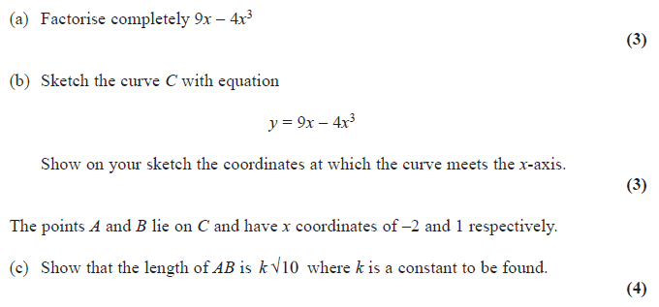**Exam Questions**

**1)**

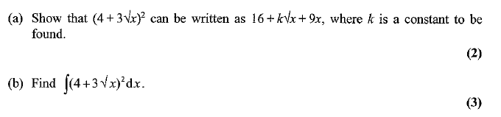

**2)**

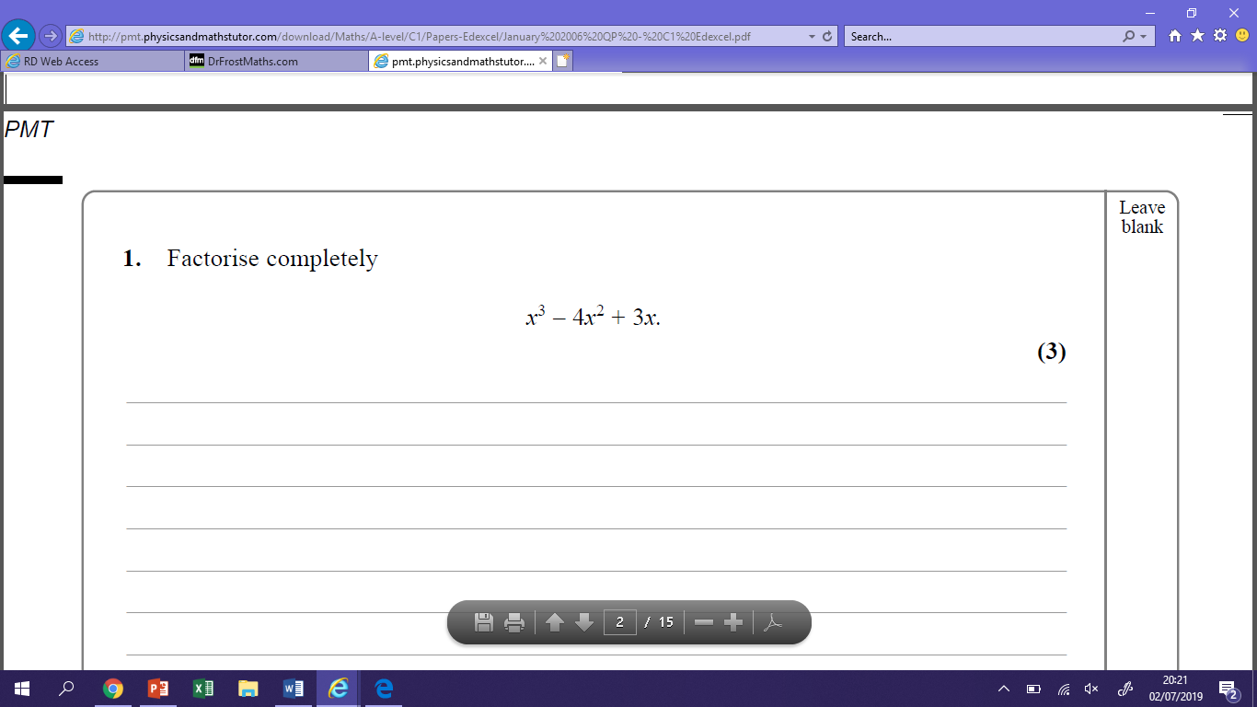

**3)**

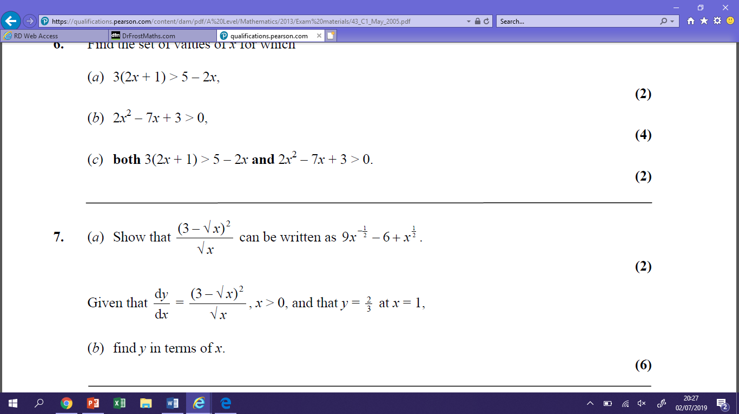**4)**

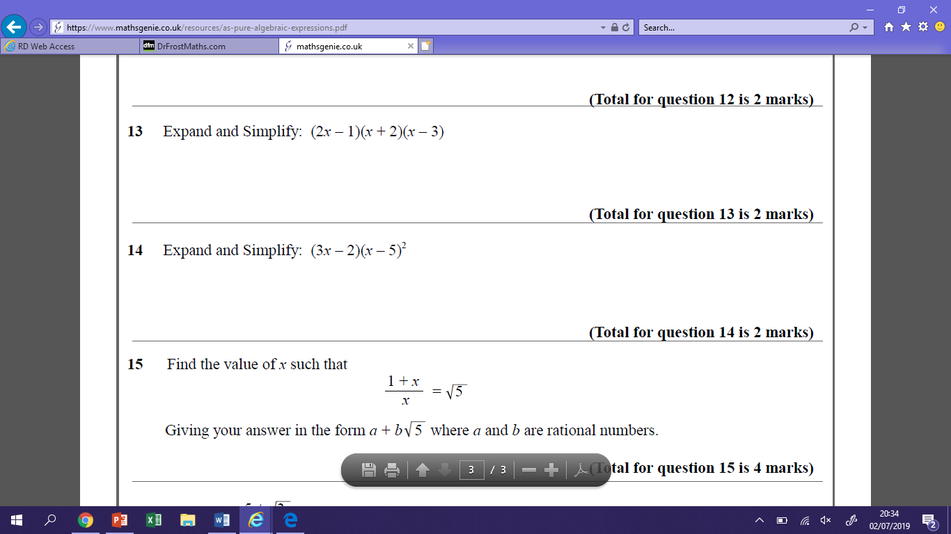**5)**

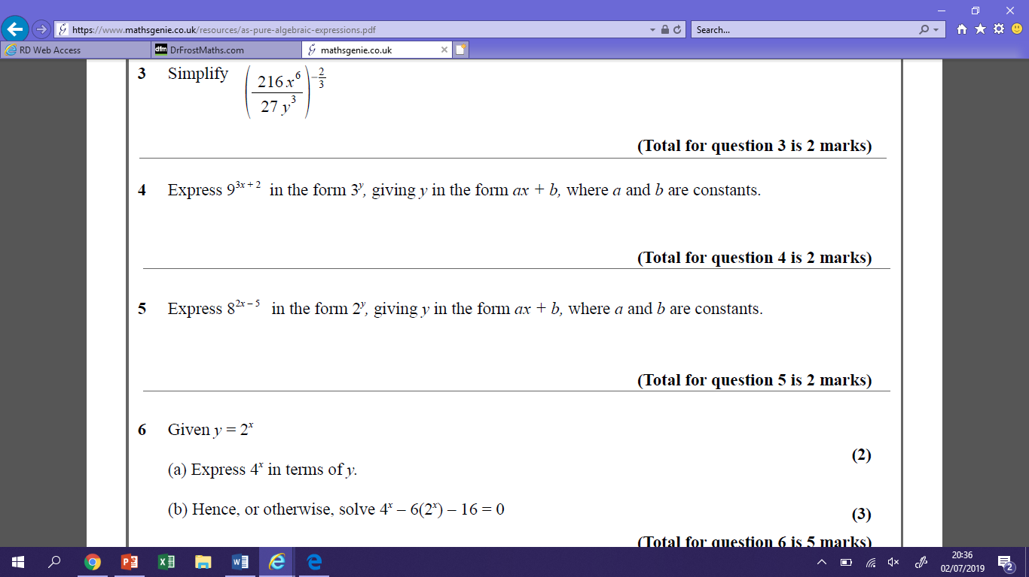

**6)**

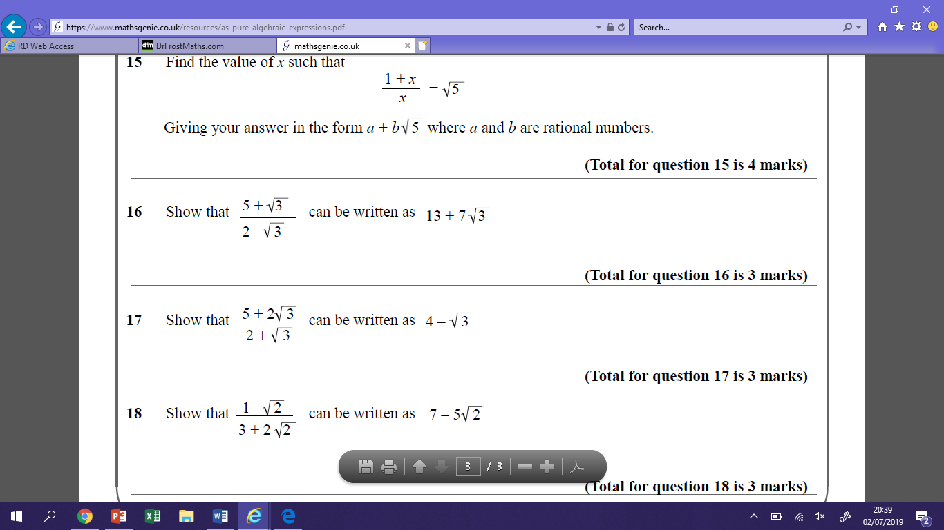

**7)**

**Quadratics**

**Practicing the Technique**

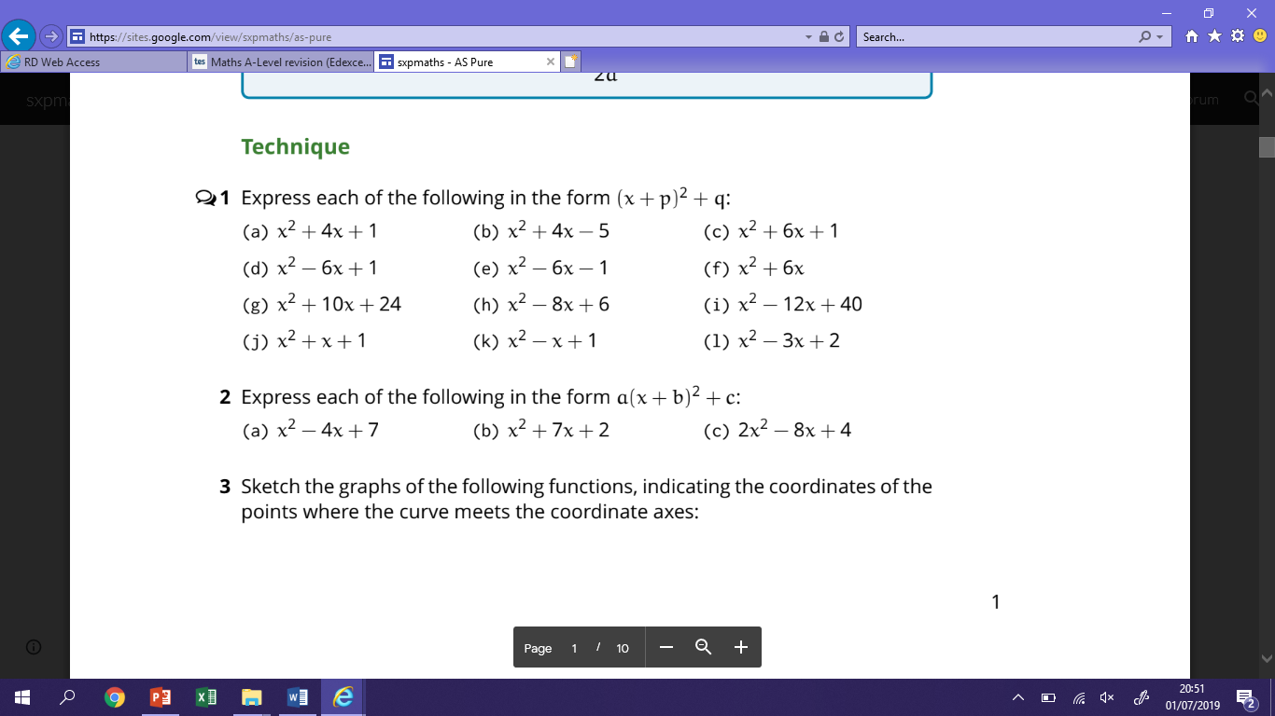

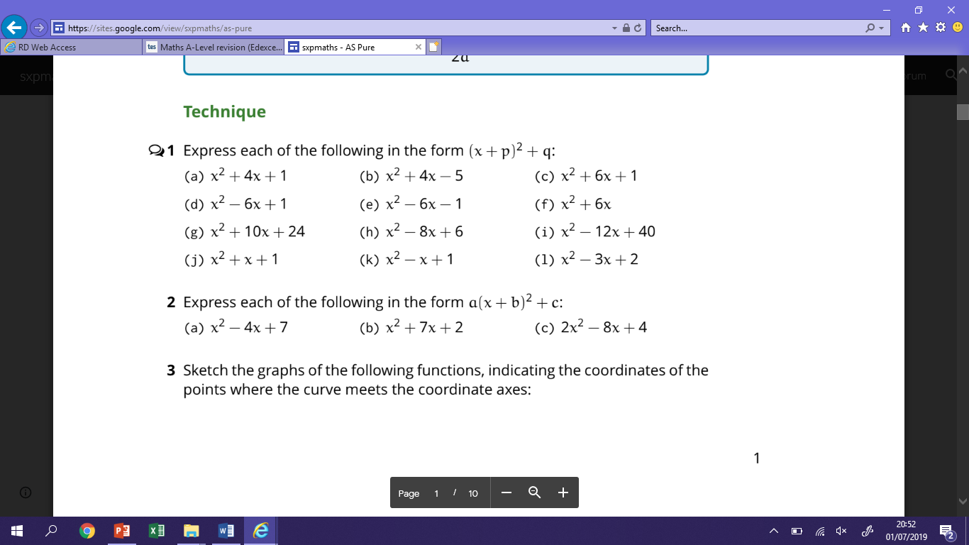

**Exam Questions**

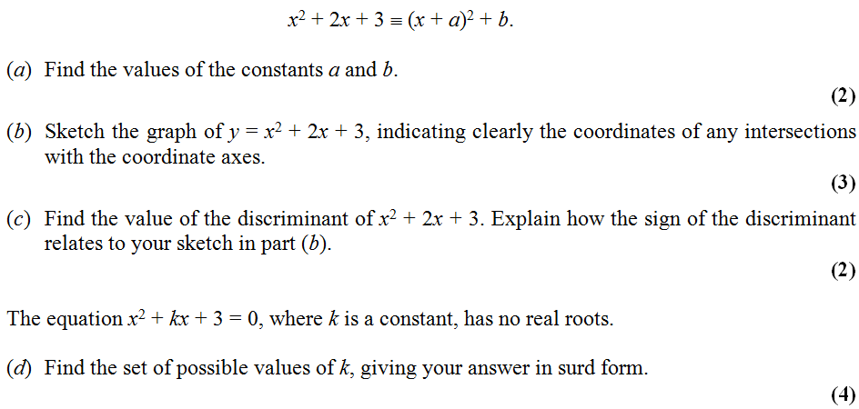**1)**

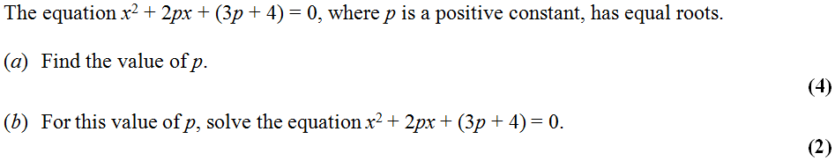**2)**

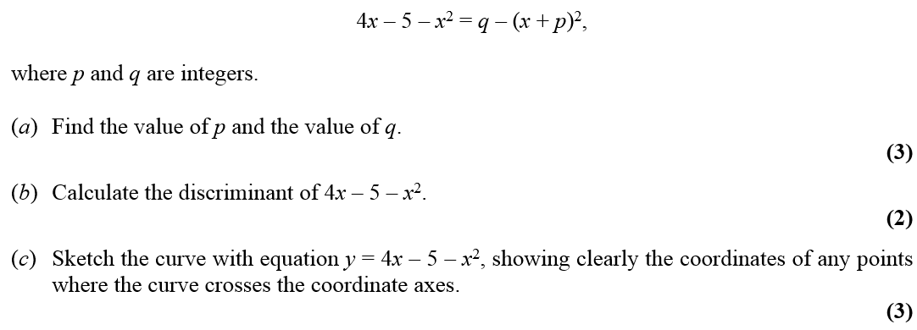**3)**

**4)** 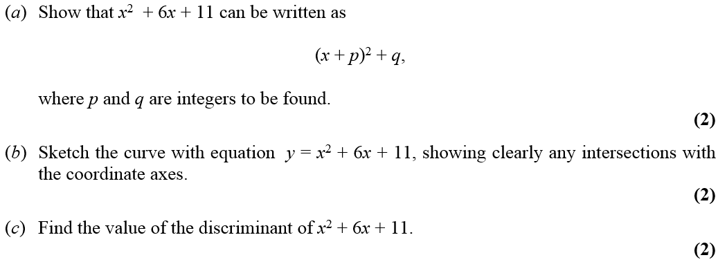

**Equations and Inequalities**

**Practicing the technique**

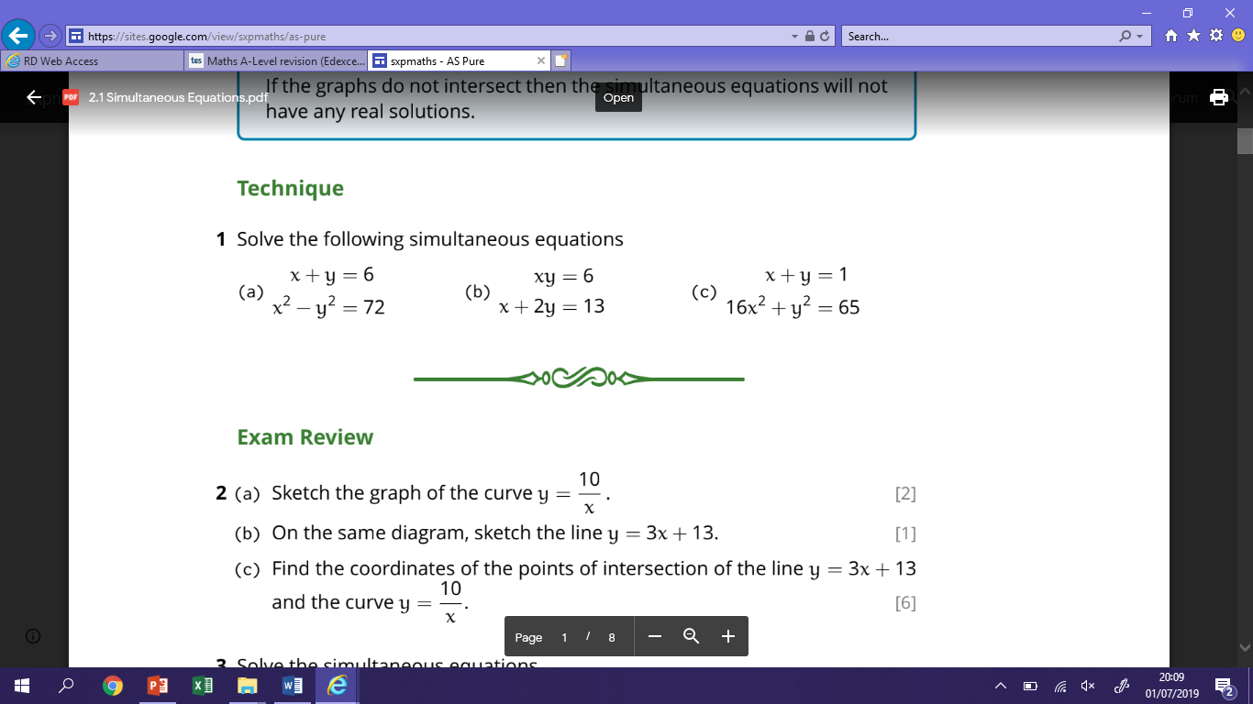

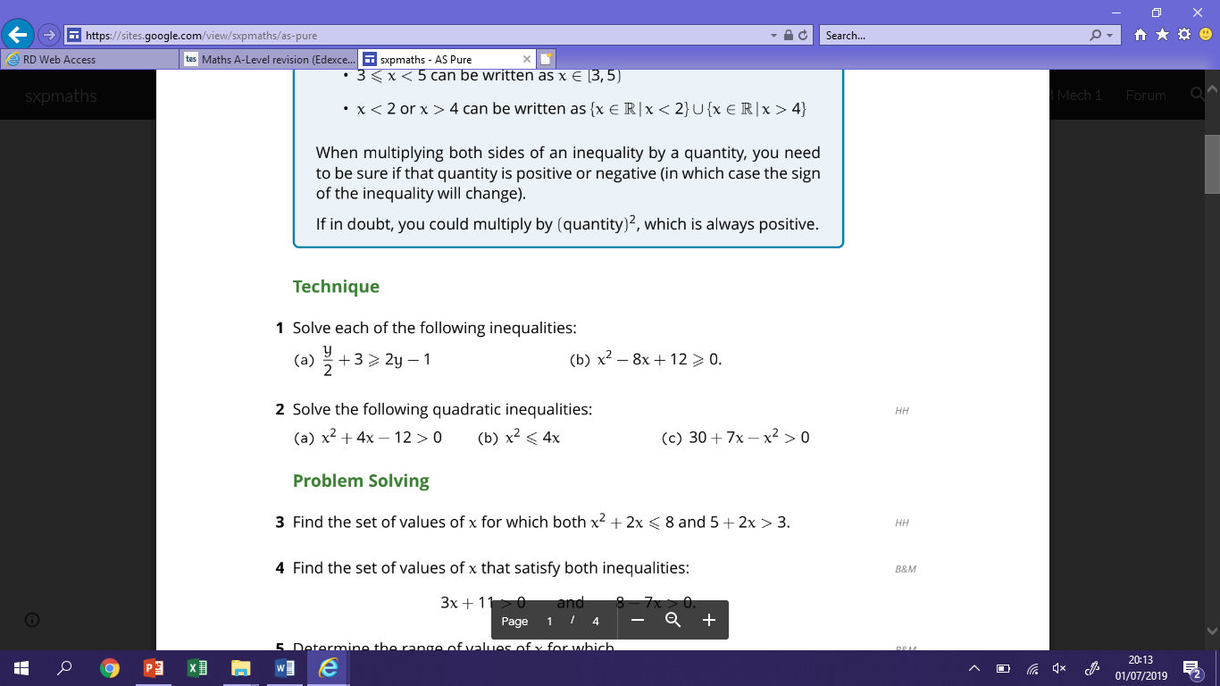

**Exam Questions**

**1)** Find the solutions to the simultaneous equations. ***You must show all working***

*y* – 2*x* = 3

*x*2 + *y*2 = 18

*x =*……………………. *y =*…………………….

or *x =*……………………. *y =*…………………….

(Total 7 marks)

2)

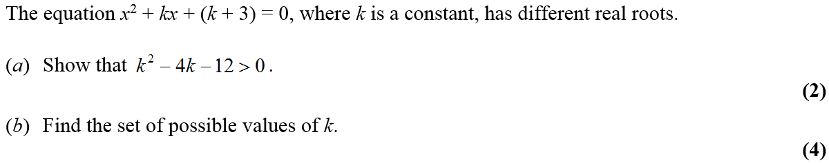

3)

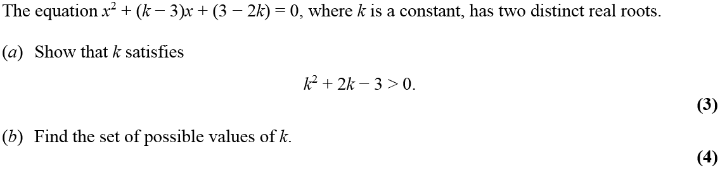

**Graphs and Transformations**

**Practicing the technique**

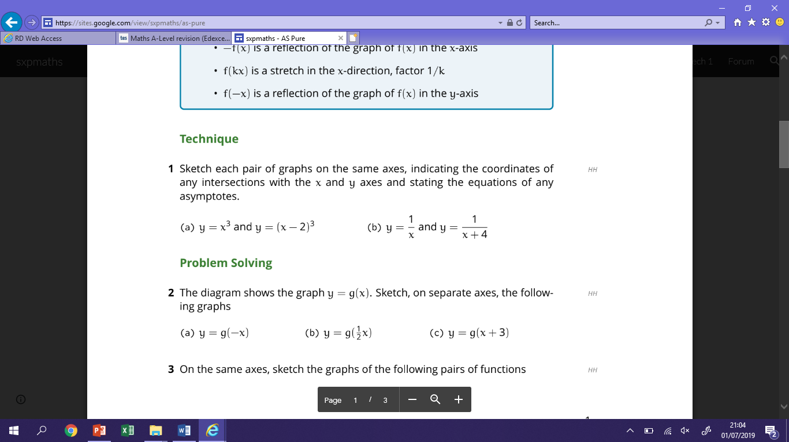

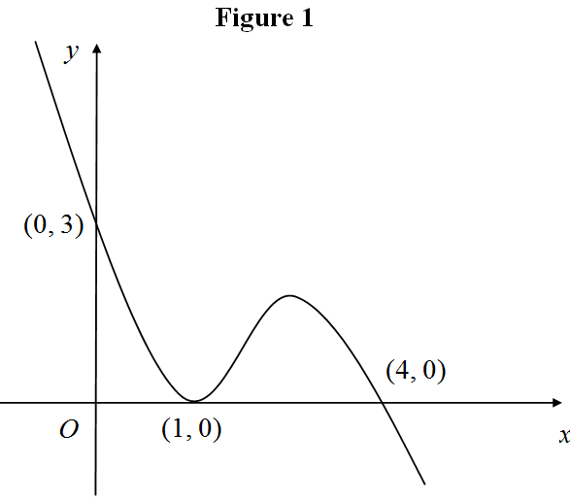**Exam Questions**

**1)** 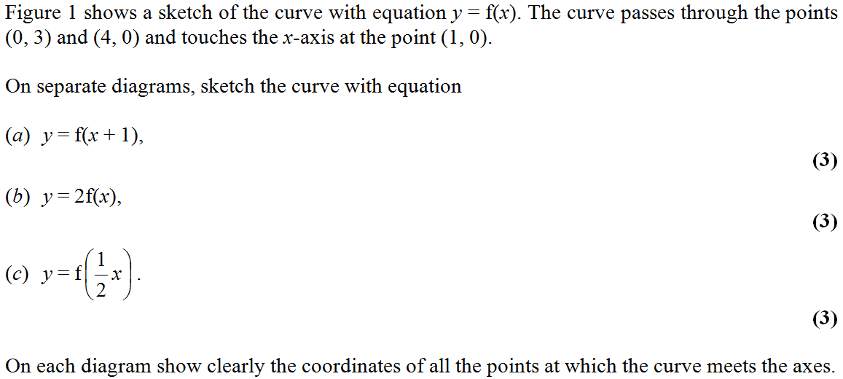

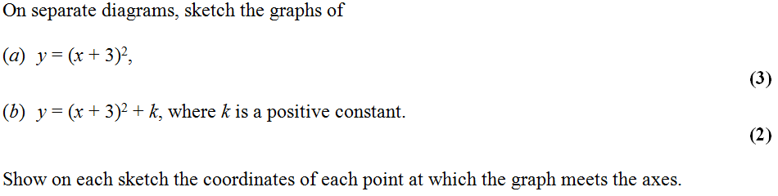**2)**

**3)** 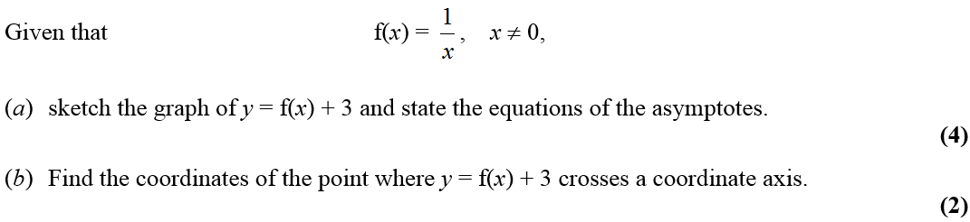

**4)** 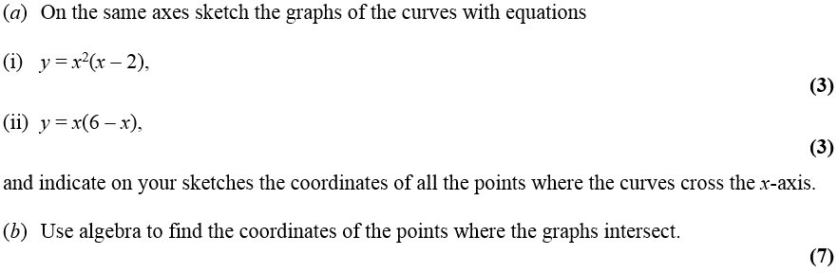

**Straight Line Graphs**

**Practicing the Technique**

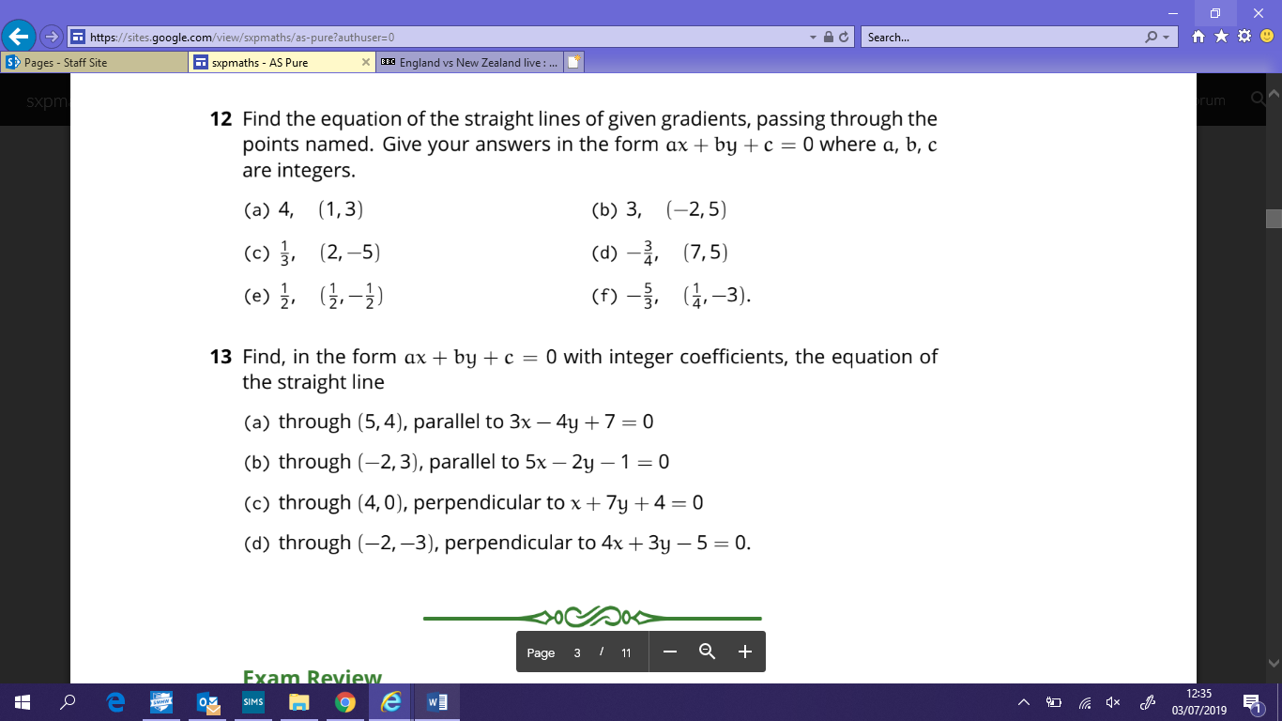

**Exam Questions**

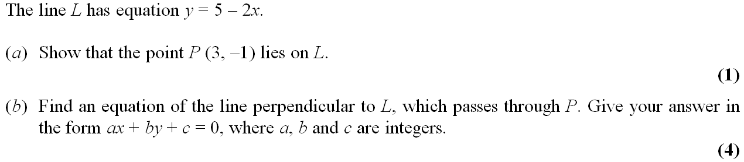**1)**

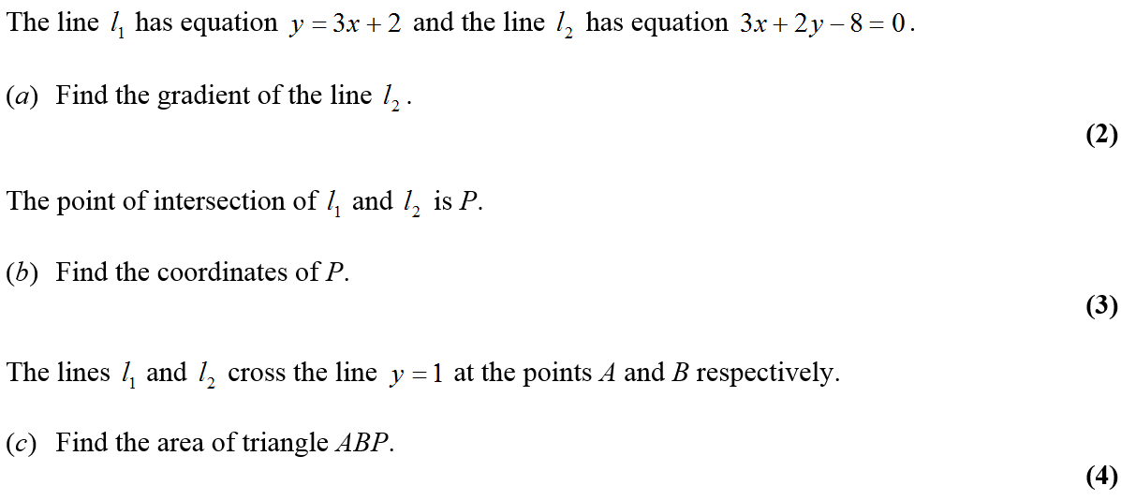**2)**

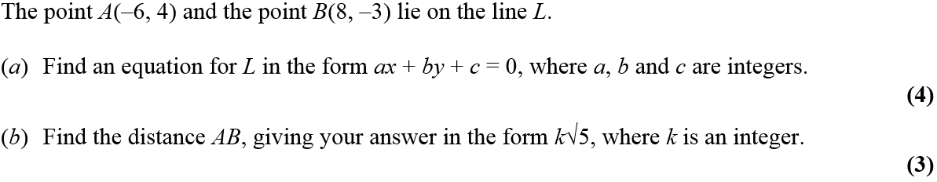**3)**

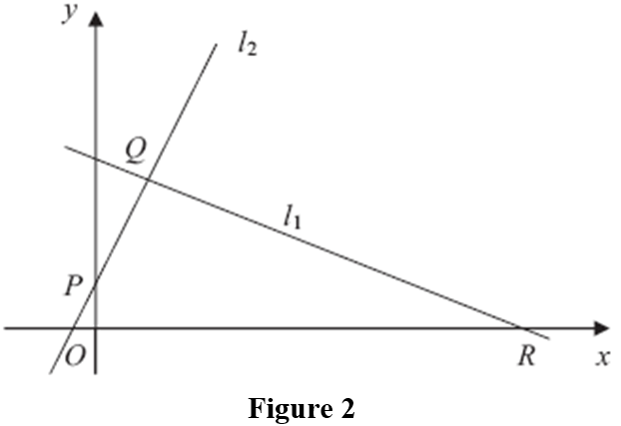**4)**

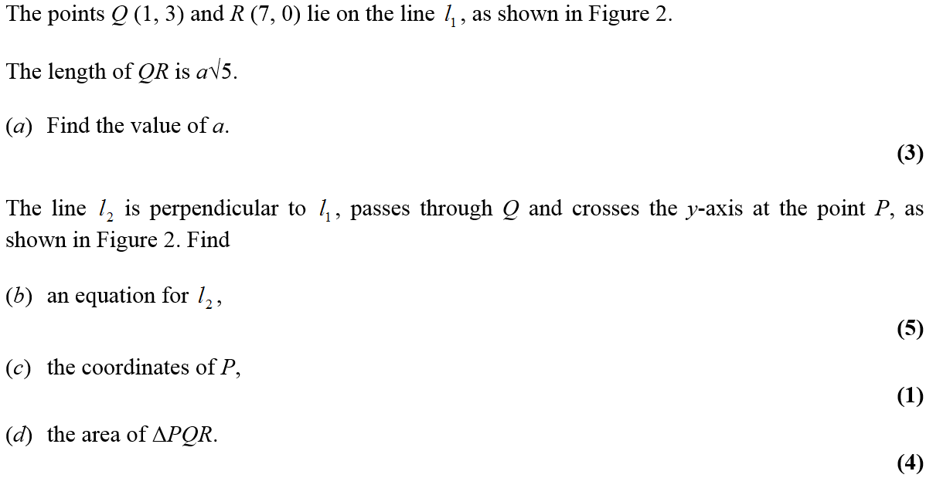

**Circles**

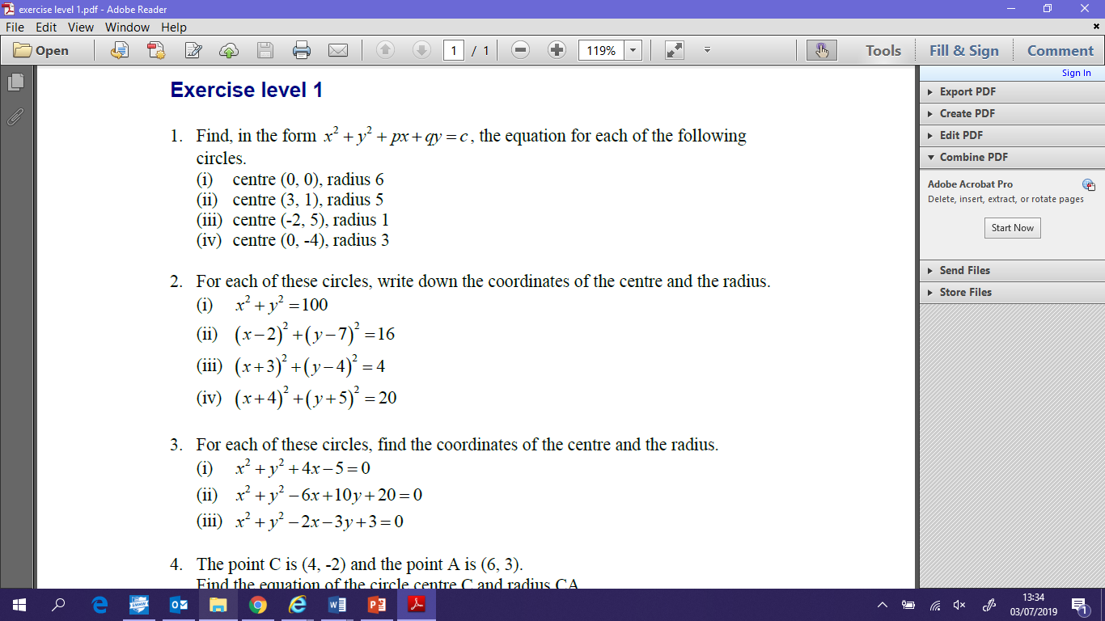**Practicing the Technique**

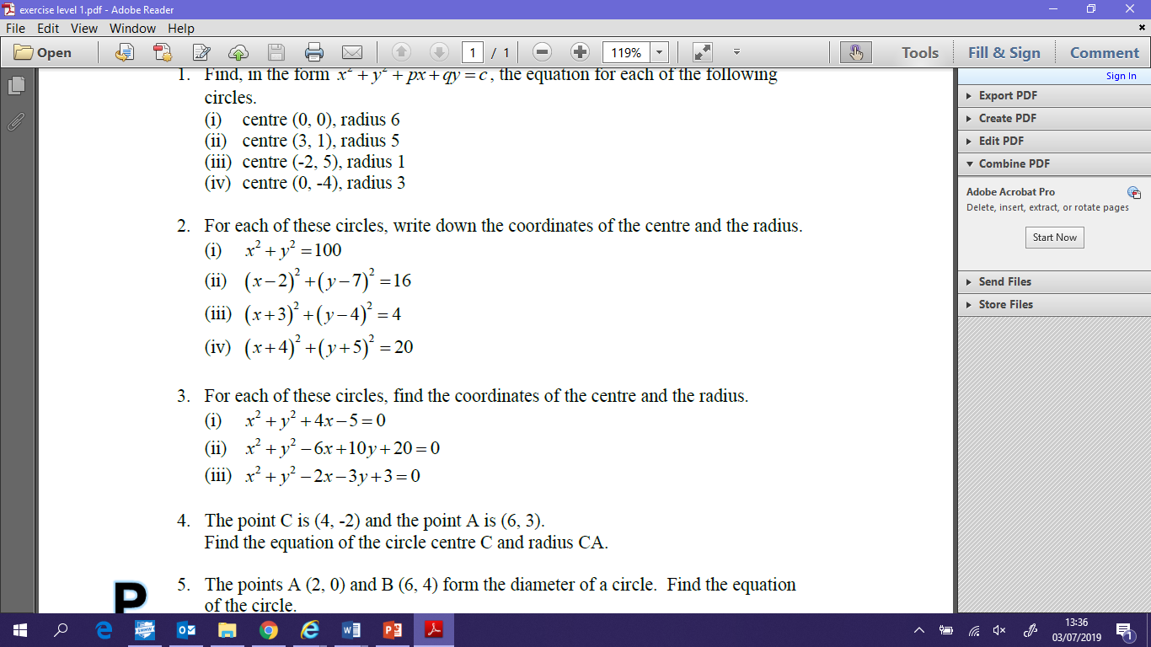

**Exam Questions**

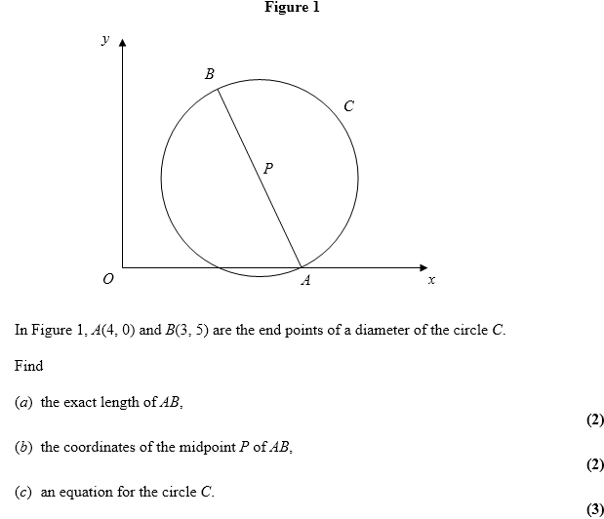**1)**

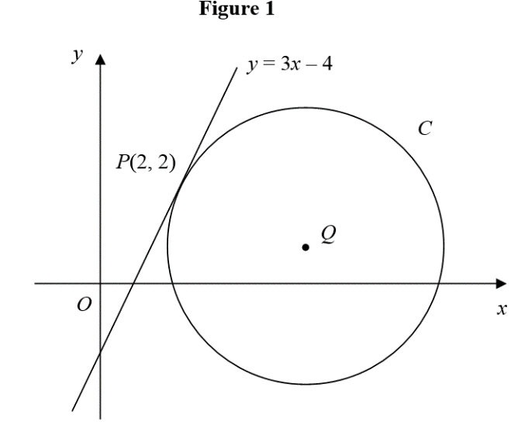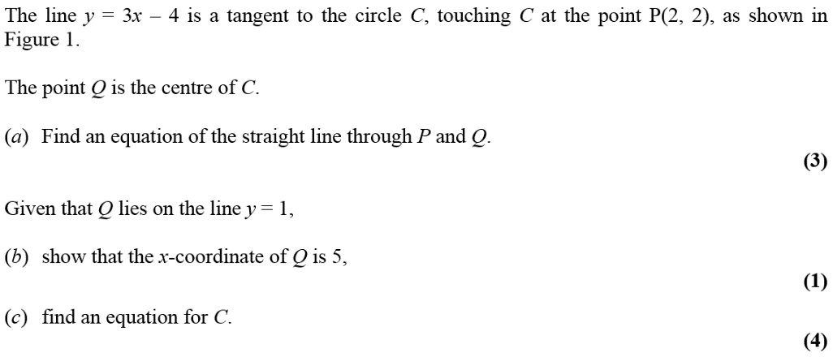**2)**

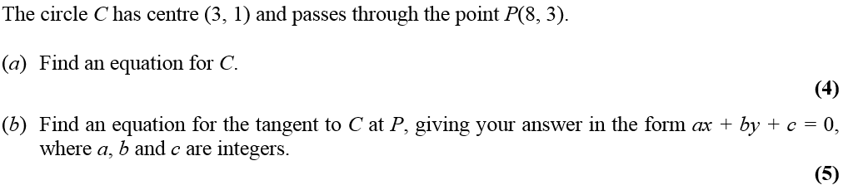**3)**

**Algebraic Methods**

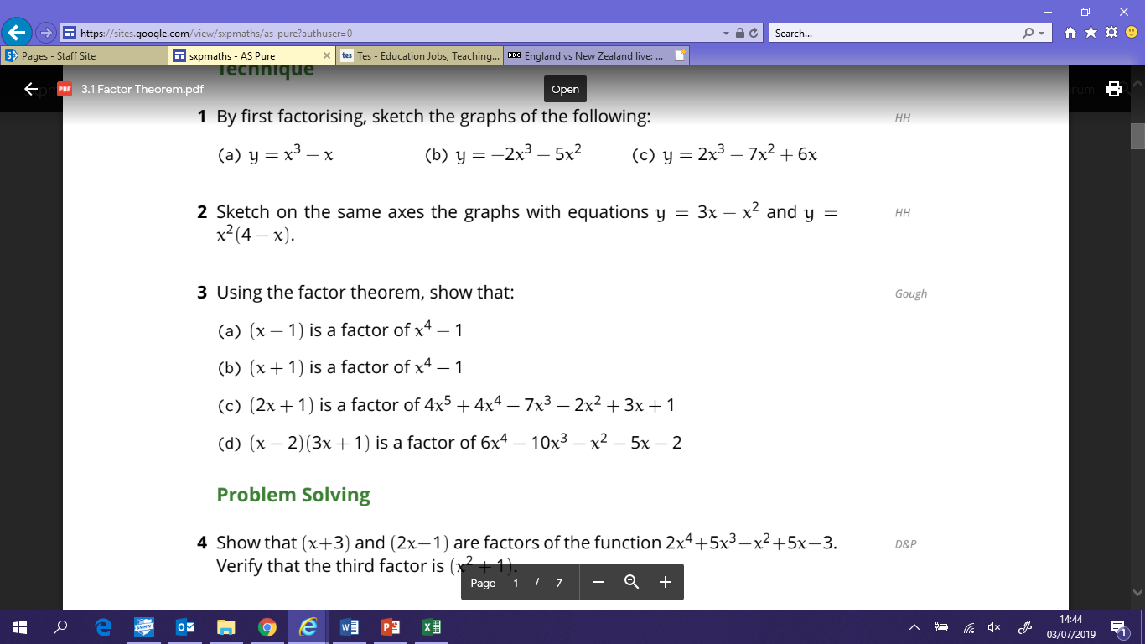**Practicing the Technique**

**1)**

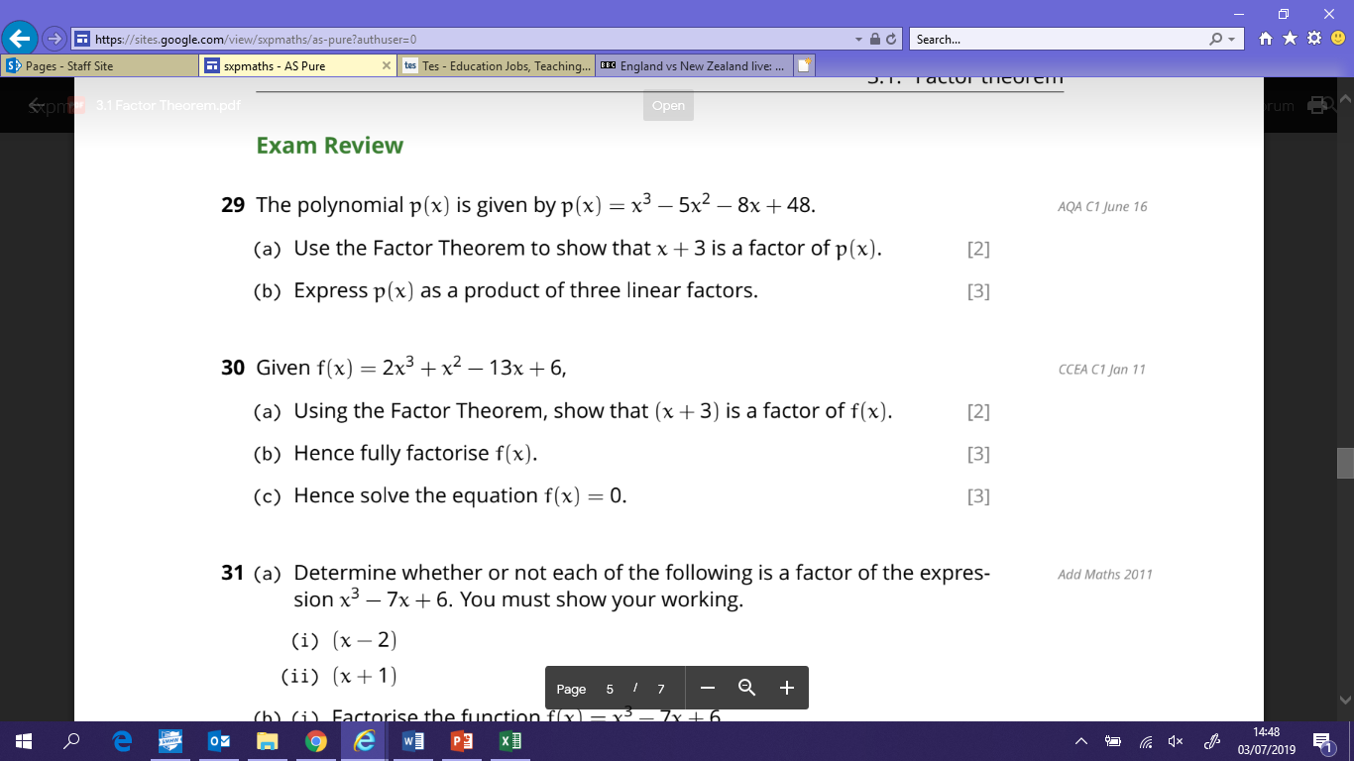

**2)**

**Exam Questions**

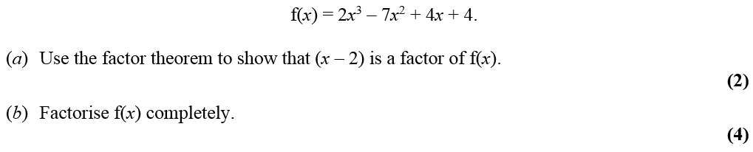**1)**

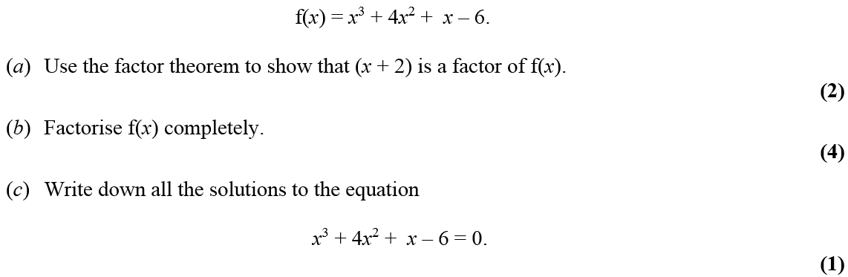

**2)**

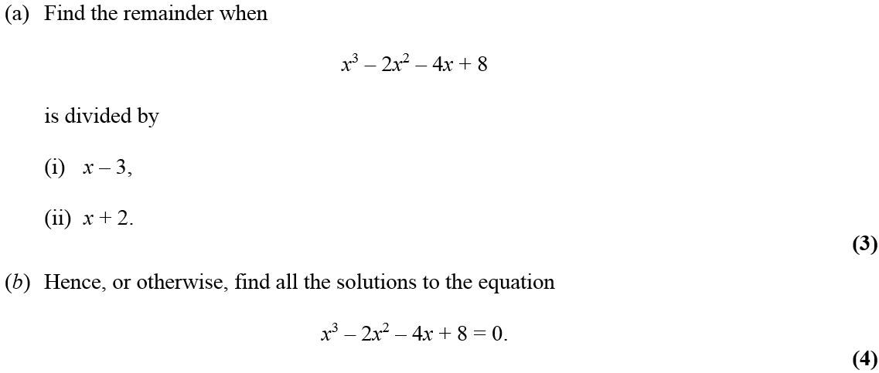**3)**

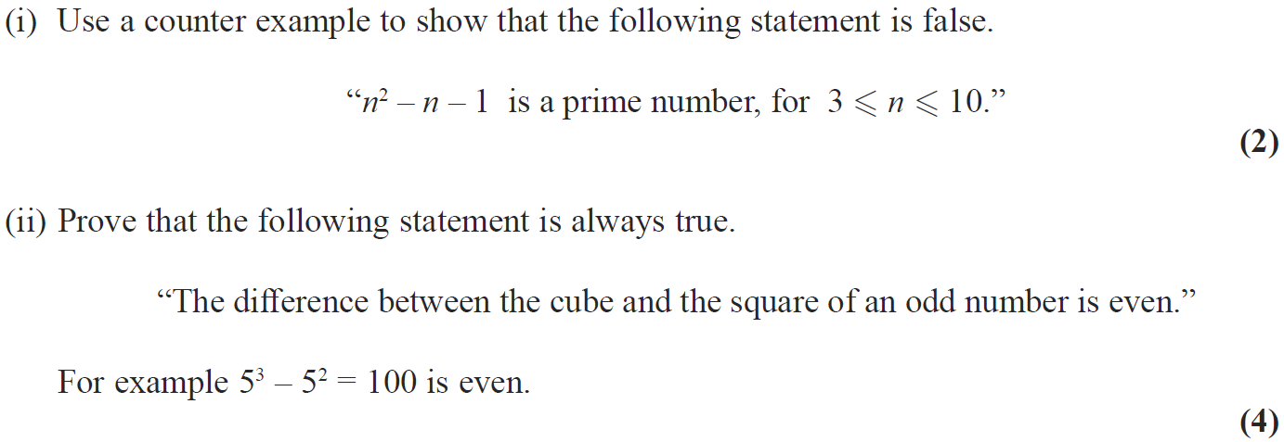**4)**

**The Binomial Expansion**

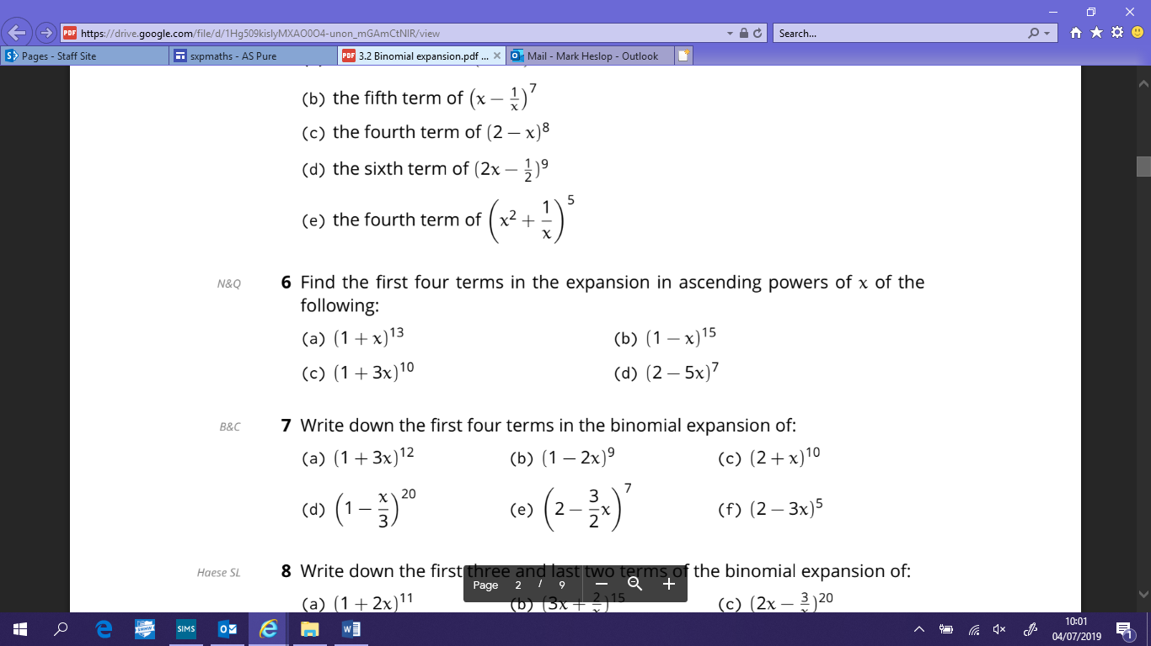**Practicing the Technique**

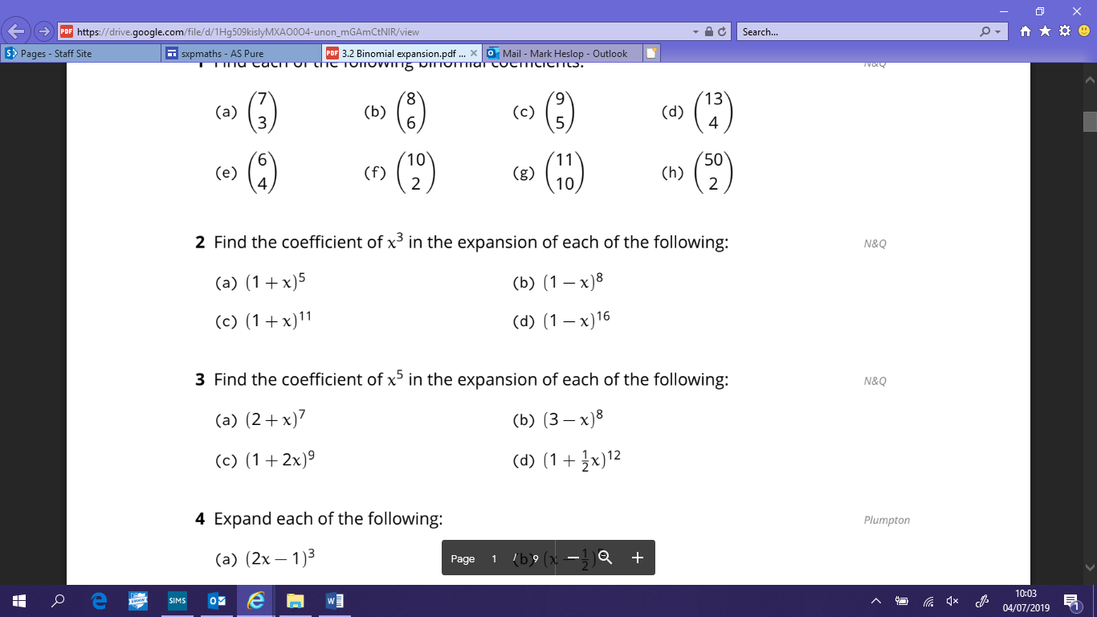

**Exam Questions**

**1)**



**2)**

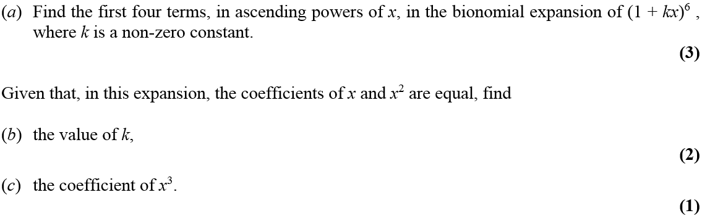**3)**

**Trigonometric Ratios**

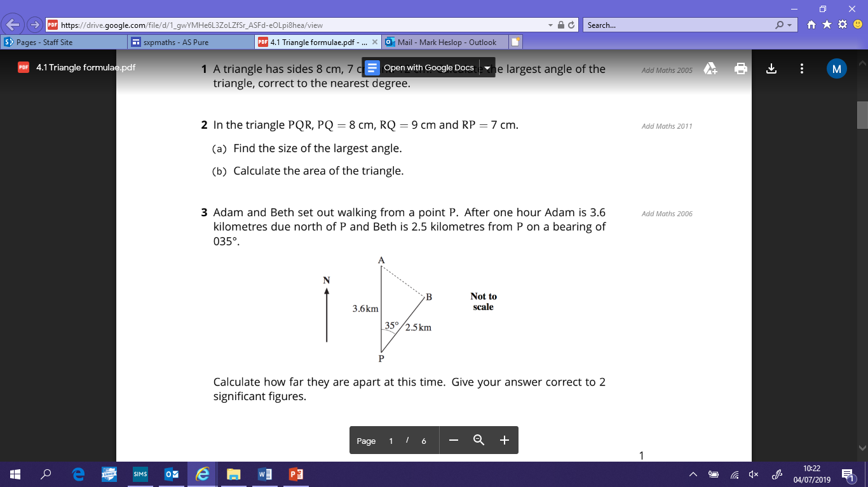**Practicing the Technique**

**1)**

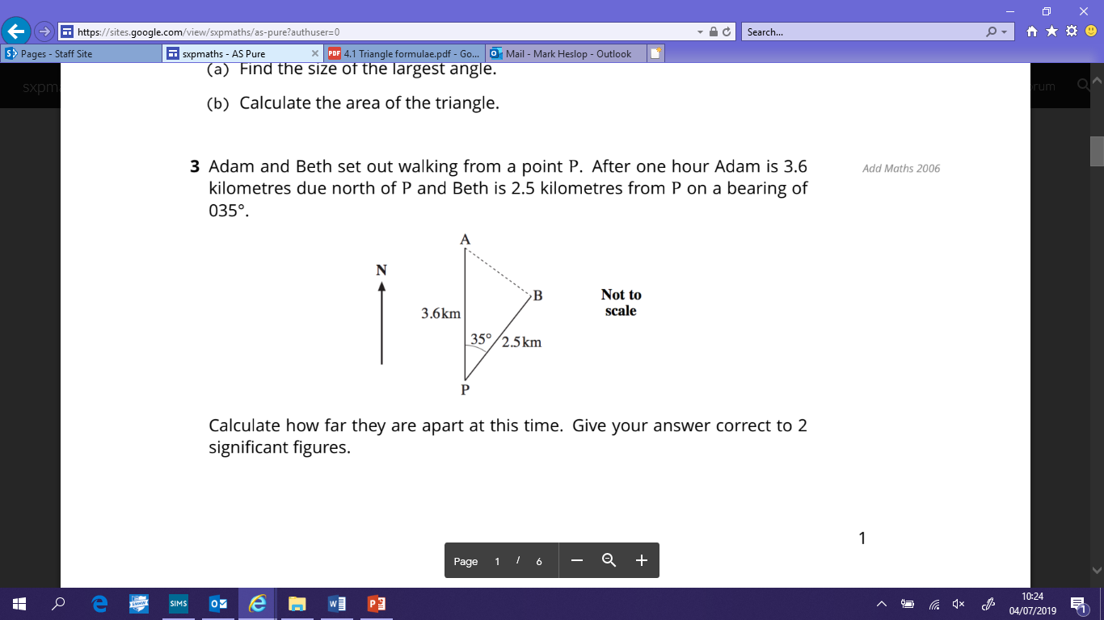

**2)**

**Find the distance between Adam and Beth after one hour**

**Exam Questions**

**1)**

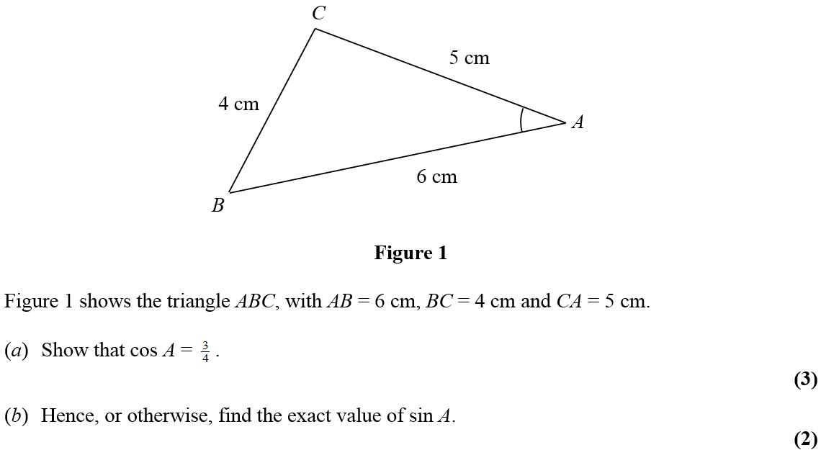

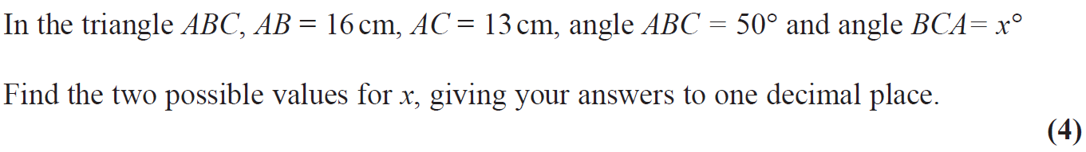**2)**

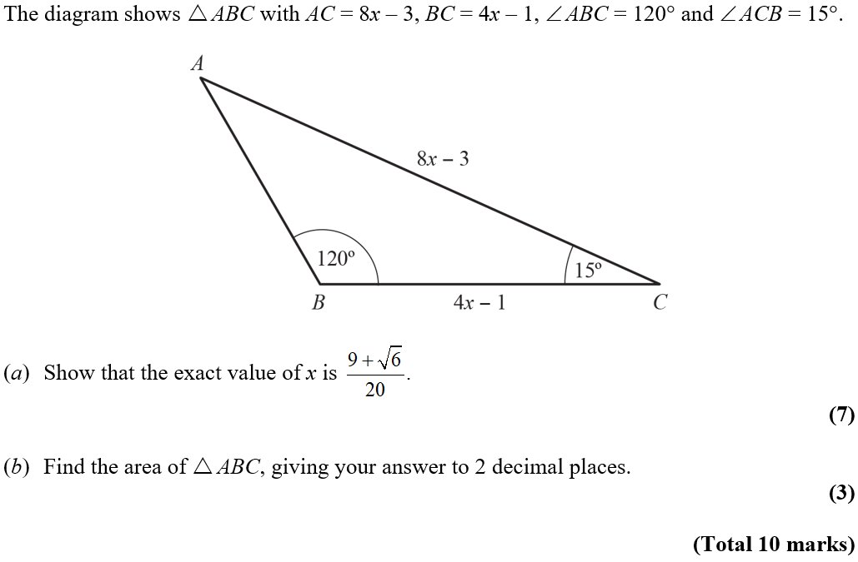**3)**

**Trigonometric Identities and Equations**

**Practicing the Technique**

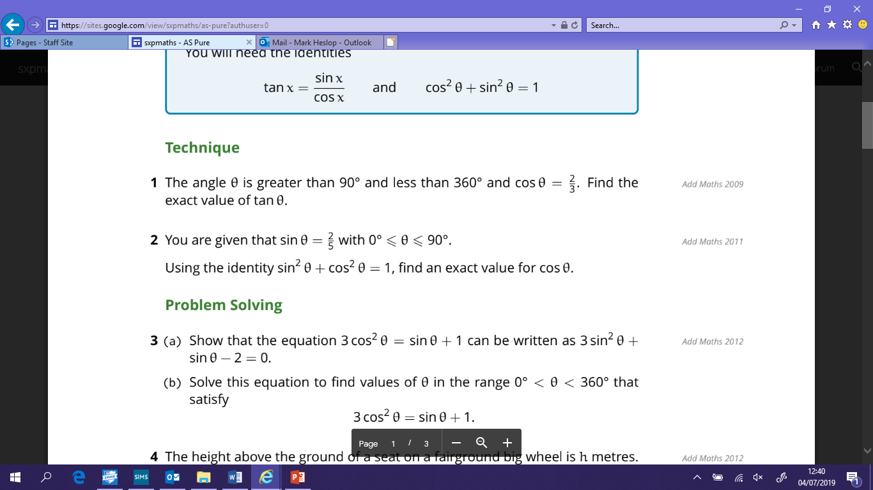

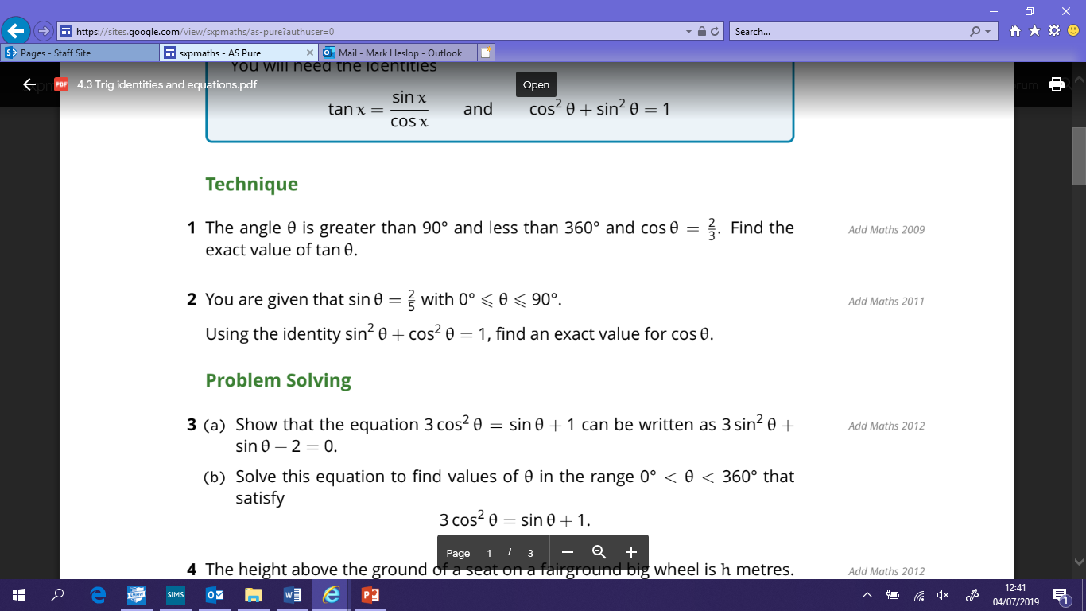

**Exam Questions**

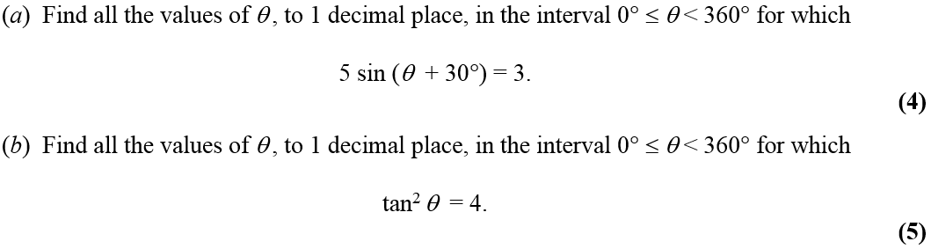**1)**

**2)** 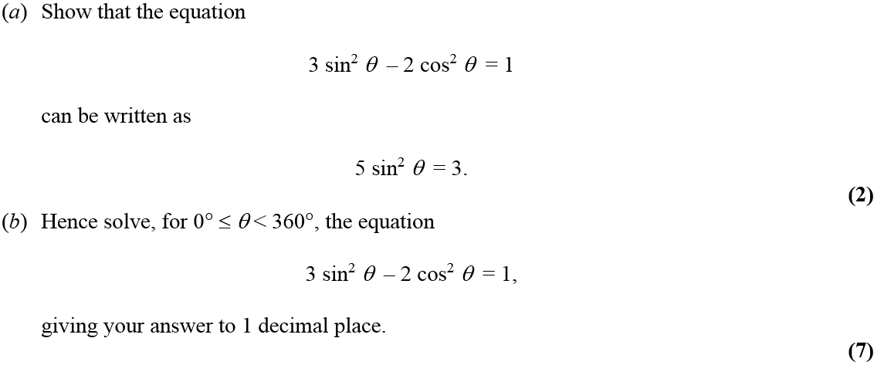

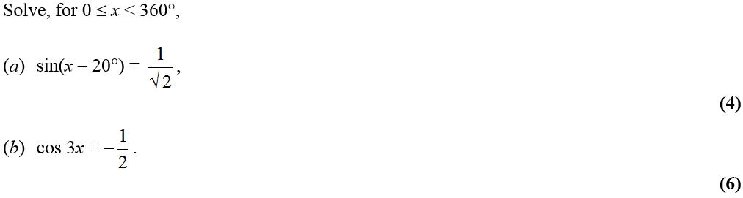**3)**

**Vectors**

**Practicing the Technique**

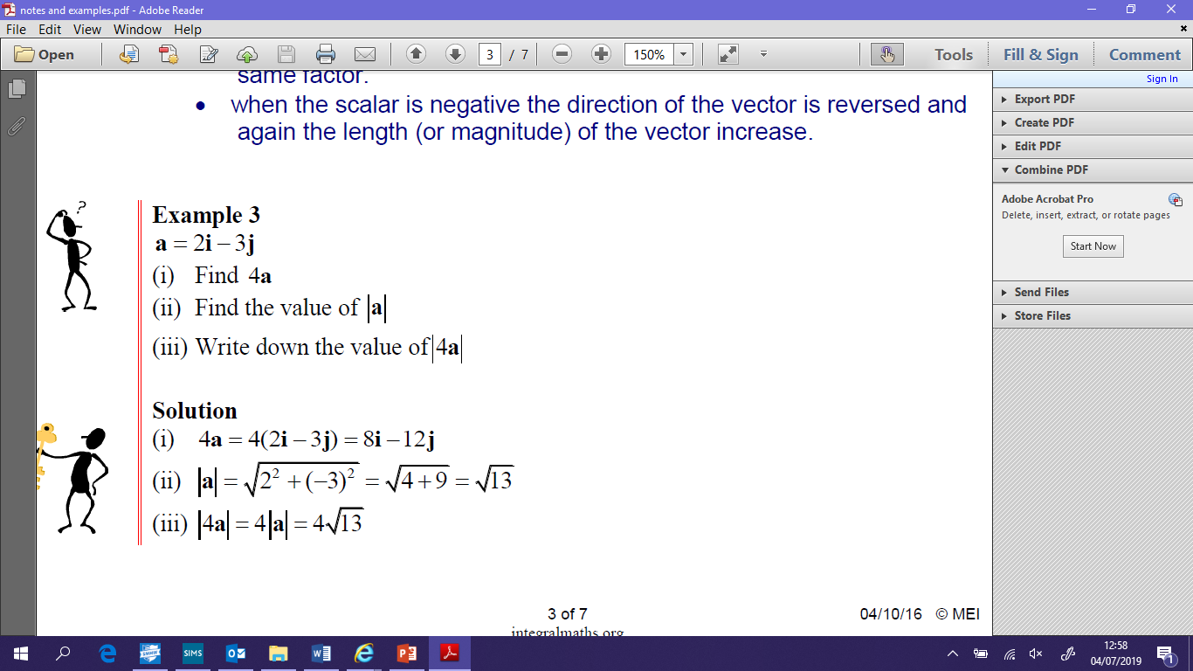**1)**

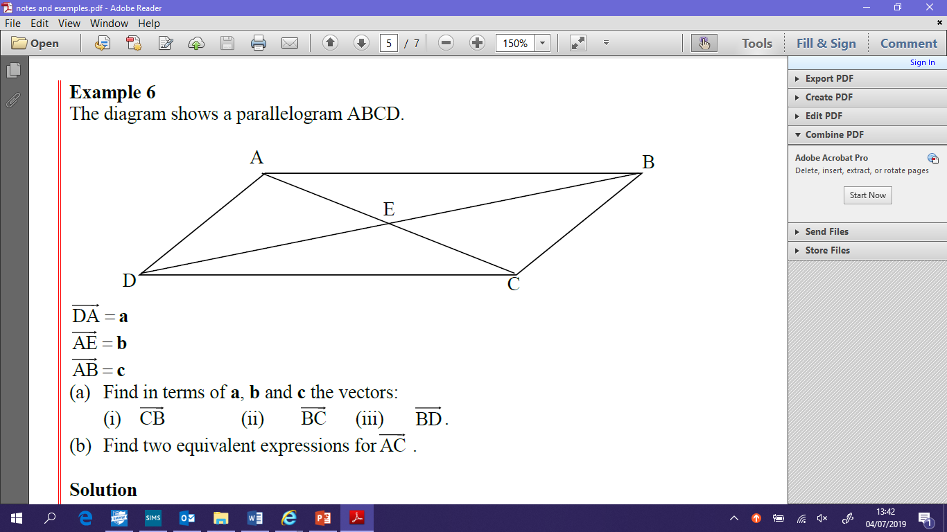**2)**

**Exam Questions**

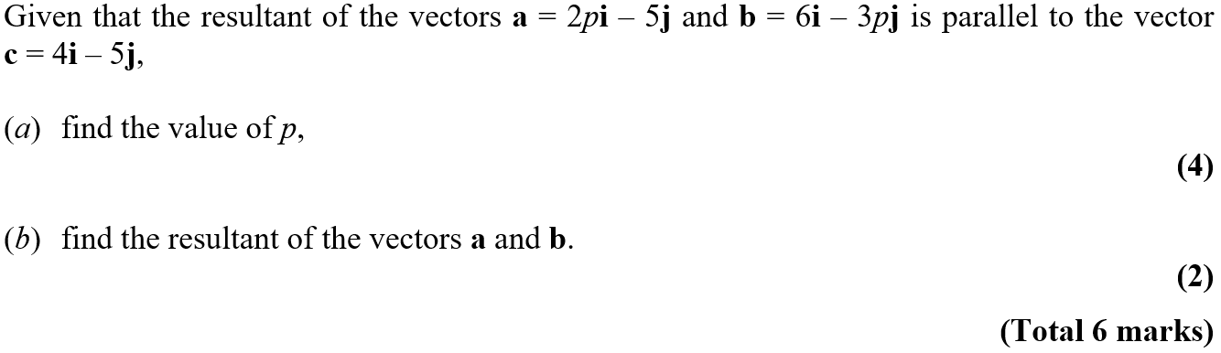**1)**

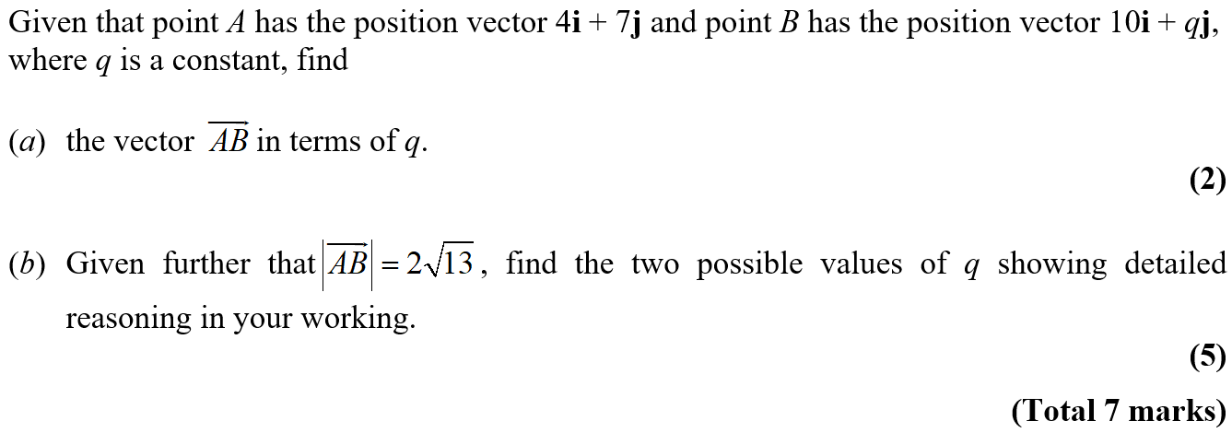**2)**

**Differentiation**

**Practicing the Technique**

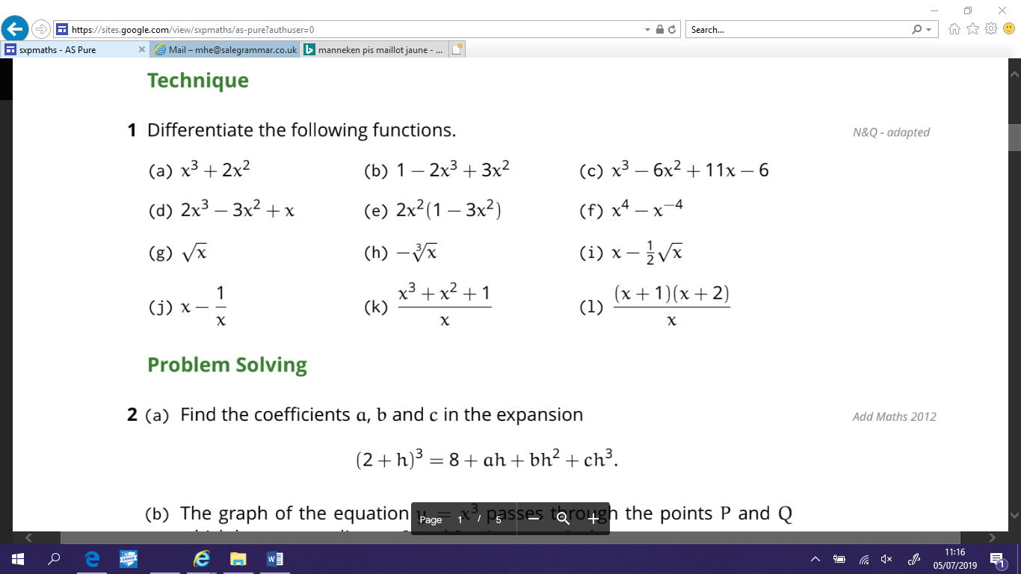

**2)** 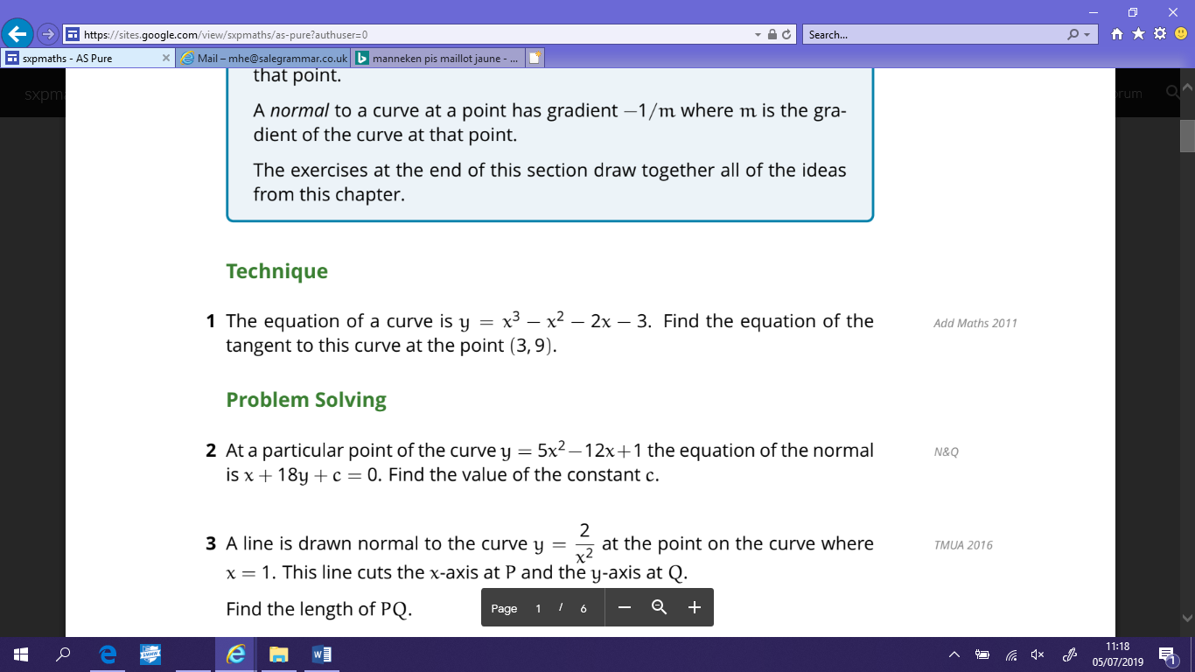

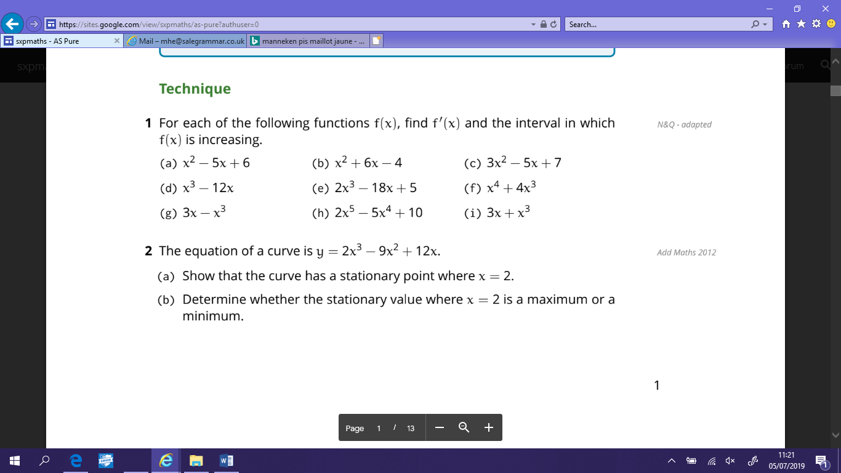**3)**

**Exam Questions**

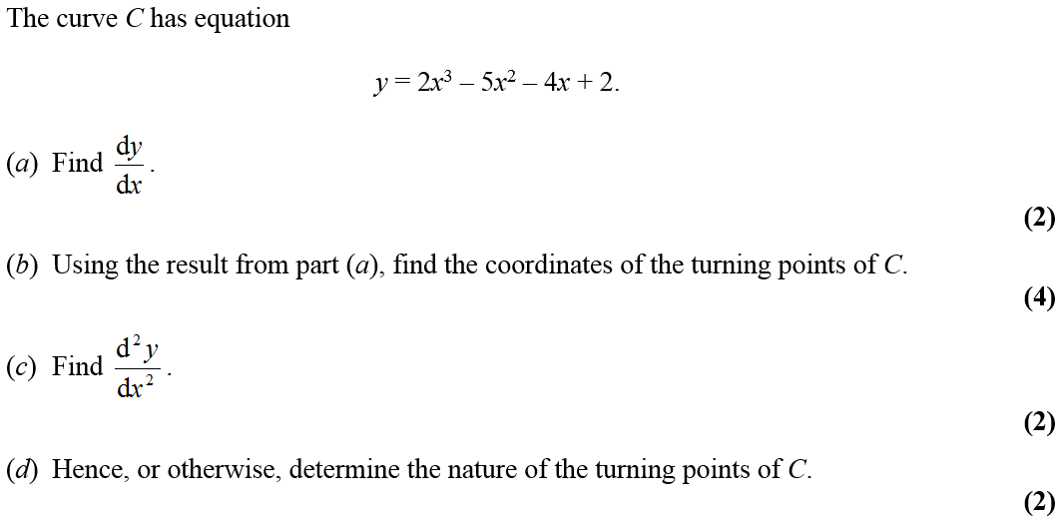**1)**

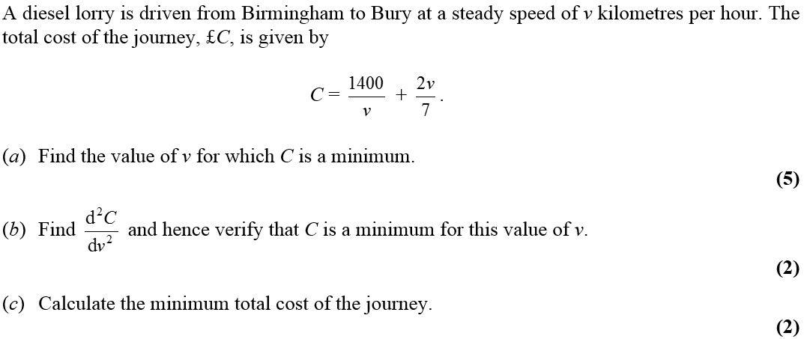**2)**

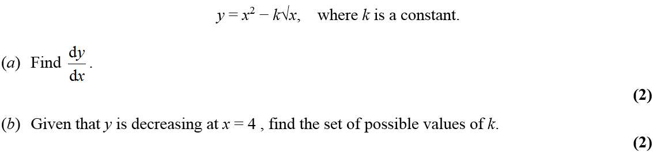**3)**

**4)**

**Integration**

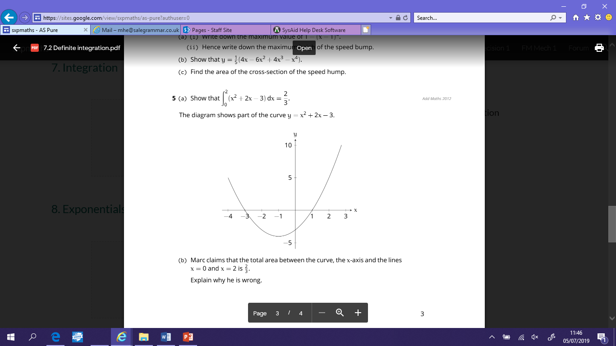**Practicing the Technique**

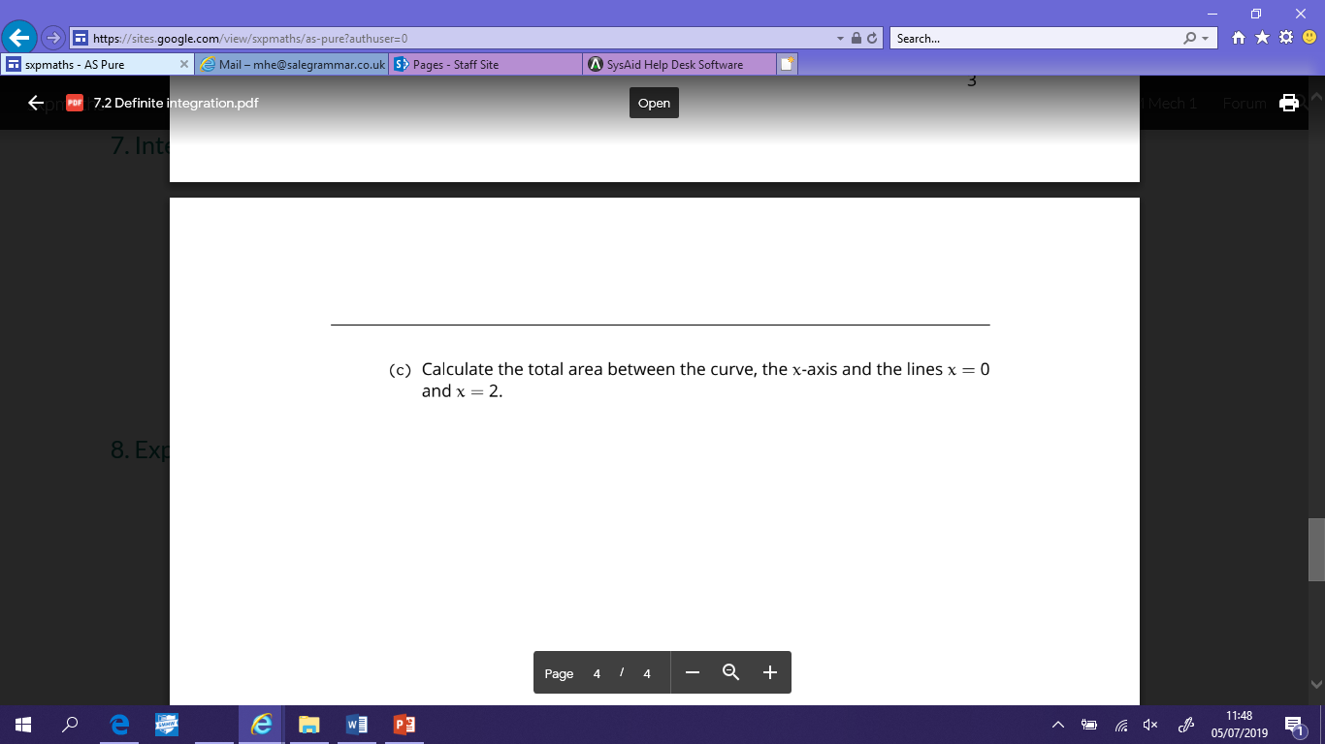

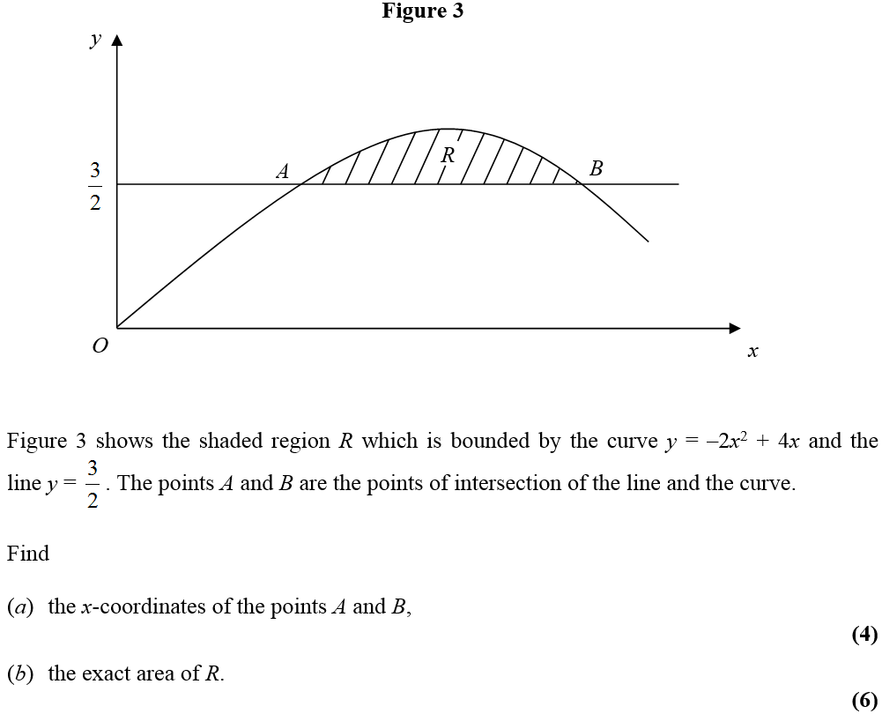**Exam Questions**

**1)**

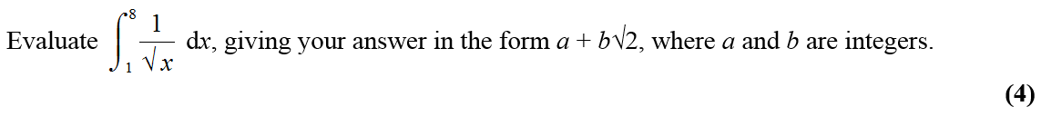**2)**

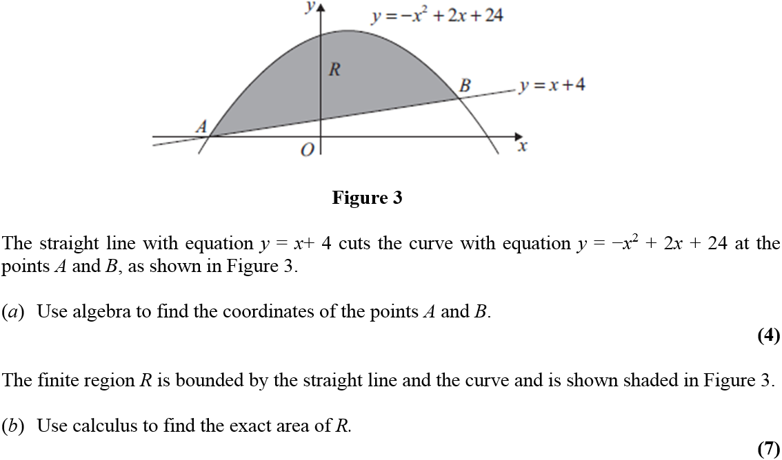**3)**

**Exponentials and Logarithms**

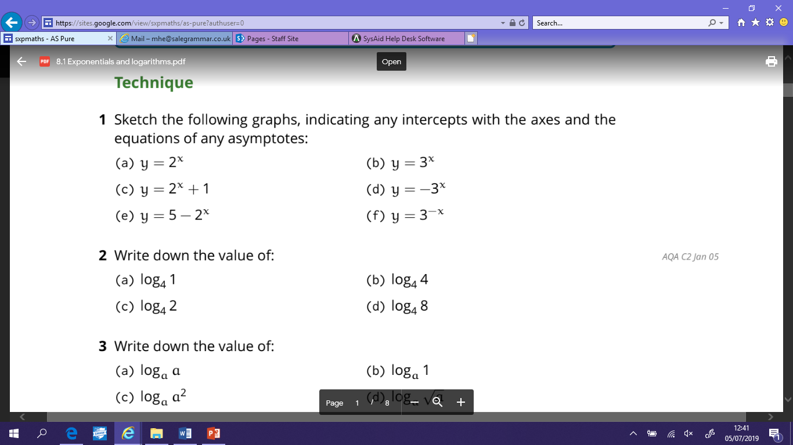**Practicing the Technique**

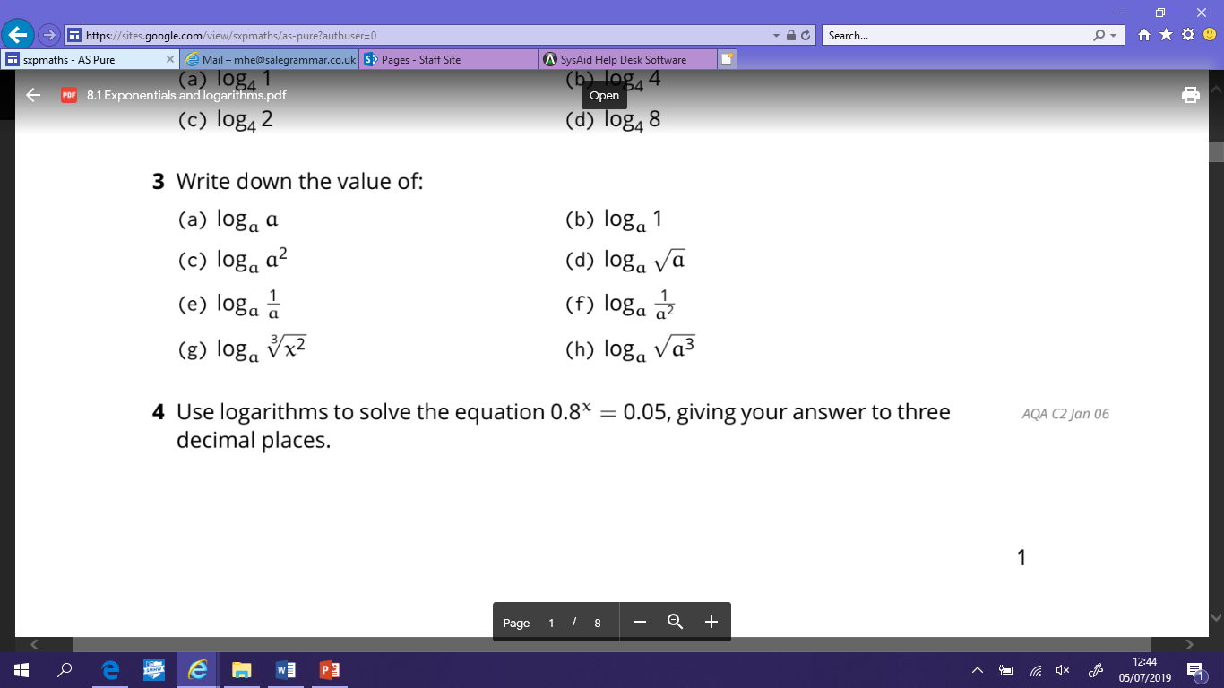

**2)**

**Exam Questions**

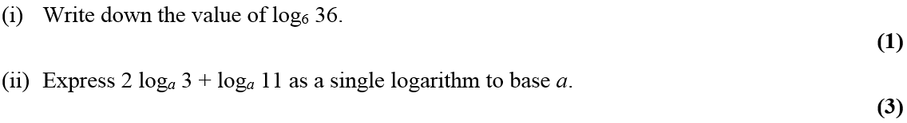**1)**

**2)**

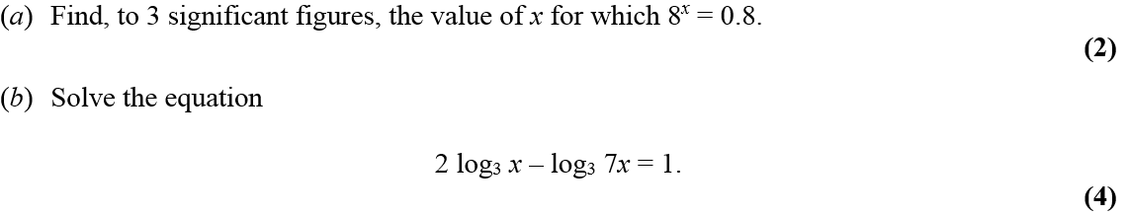**3)**

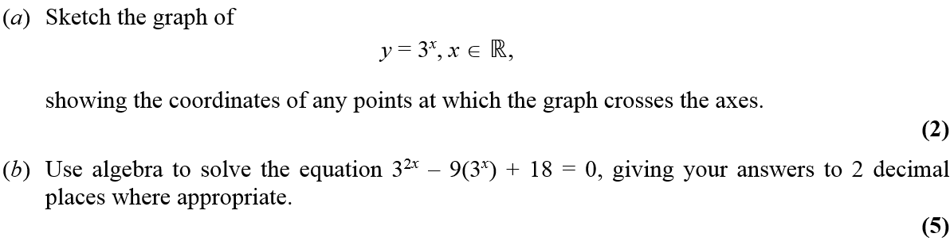**4)**